Transferability document

PROJECT:

|  |  |
| --- | --- |
| **Project name:** | Additive Industries |
| **Date completed:** | … |
| **Author(s):** | Blom,Robin R.J.M.M.  Conradus,Anaïs A.G.L.  van Dinter,Daniel D.J.M.B.  van Gestel,Richard R.A.T.  Geurts,Lucia L.  Petrişor,Rareş R.I.  Peterse,Jacek J.J.  Tamerat,Efaliso E.  Verhage,Maurits M.S.A. |
| **Stakeholders:**  **Version:** | Huisman,José J.A.T.M.  1.0 |
| **Status:** | In progress |
| **File name:** | Transferability Document LowCode.docx .docx |

# Research Themes

Within the minor ‘Data Driven Business Lab’, Brainwave carried out a project for Fontys Hogescholen according to one of the following six research themes of FHICT:

* Artificial Intelligence
* Applied Games
* Data and Software Services
* Digital Communities
* Human Capital
* Robots

The research theme for the LowCode project is data and software services. The goal of the project is to investigate how Fontys can optimize their project management by standardizing and automating this. The main-end product will be a Proof-of-Concept in the form of a Power Automate flow with a Power BI dashboard.

# Assignment and main-research question

The project consists of the following main-question.

**Main research question:** *How can Fontys optimize and centralize their way of working regarding project control with a Proof-of-Concept?*

With this main-research question, our assignment was to design a project management system as Proof-of-Concept with the software from the ‘Microsoft Power Platform’ to enable Fontys executives to gain insights in the possibilities of the ‘Microsoft Power Platform’ that can help with optimizing and centralizing the projects. It ultimately enables Fontys employees to have control over all the projects that are executed within Fontys Hogescholen.

The next groups can use the Proof-of-Concept to build a prototype as project management system with the gathered information that Brainwave provided.

# Context

Brainwave is going to help Fontys with a new project management system. This project is for the ICT institute and leads as an example for how the project management system is going be implemented throughout Fontys at a later stage. These projects are set up by professors that want to do one of the following: Enhance study quality, research, or create new learning material like minors, studies, or courses for external firms. Before a project can start, it first needs to be approved by several employees in other departments. The amount and type of approvals depend on the project budget and the funding source. There are three ways for a project to get funded. Firstly, by having Fontys pay for the project using internal budgets. Secondly, via "Zakelijke Dienst" this department works with external firms to gather funding for projects or create a course for that firm. Lastly, subsidies from governmental or other institutions (R. Lippits, personal communication, September 13, 2021).

# Results

This chapter contains the most important results, deliverables, and insights of our project. The added value of the these will be measured by applying the ‘TRLevel Positioning’.

## Research Document

This document contains research on the requirements from the stakeholders (TRL level 3), the technical design choices for the ‘Power Automate’ workflow and the ‘Power BI’ dashboard, and the findings we turned into advice for the making of the prototype. The validation of these results is mainly done by product reviews by the client, content coach and stakeholders.

The added value for the research document mainly resides on the fundamental research and applied research to find the possibilities of the ‘Microsoft Power Platform’ software as a project management system. It also has added value due to the advice that we gave to improve the Proof-of-Concept and make it into a prototype to ultimately implement the prototype within Fontys Hogescholen.

## Power Automate Flow

By using the research on the requirements from the stakeholders, we could set up an workflow in ‘Power Automate’ using ‘Microsoft Forms’ and ‘SharePoint lists’ (TRL level 4 and 5).

The Flow is validated by the client to make sure the Proof-of-Concept has the expected result.

The added value of this flow is being able to show Fontys the possibilities of having a structured process of the project request process. This flow will keep the process clear, efficient and effective.

## Power BI Dashboard

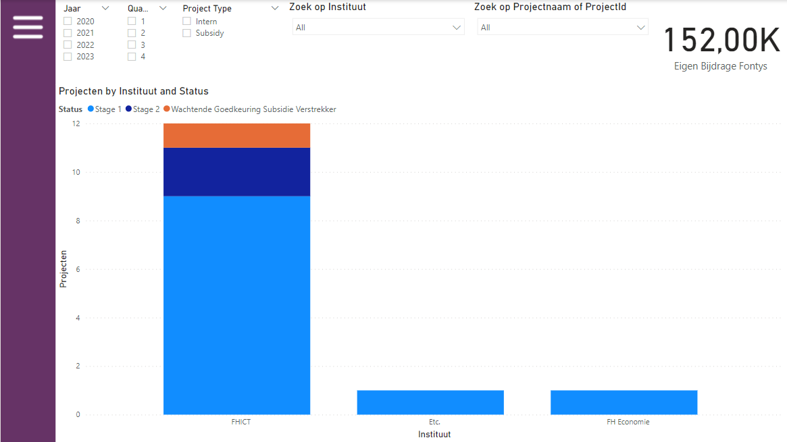By connecting the ‘SharePoint’ lists to Power BI, we could structure the data and make a relational data model. By creating this dashboard, we could give the client an overview for the different projects on 5 different levels (TRL level 4 and 5):

Figure 1: Institute Overview in Power BI

* The Center Of Expertise
* Institute Overview (see figure 1)
* Project Controller Overview
* Initiator overview
* Project Overview

The dashboards are validated by the client & content coach to make sure the Proof-of-Concept has the expected result.

The added value of this dashboard is having a clear overview of all the projects that are currently being, or have been, executed by Fontys for the direction of Fontys, project controllers or the initiators themselves.

# Methodology

This chapter explains the step-by-step description of the project according to the ICT research method: ‘The DOT-framework’ (ICT research methods, n.d.).

These are the categories in which all the research methods are included in:



Showroom Workshop Library Field Lab

The following chapters will give information of the methodology used in the sub-questions.

## Sub-question 1

This sub-question starts with interviews from the Fontys staff. Rutger has provided Brainwave with a list of employees who all have a role in the subsidy projects. These analyses are used to establish the current situation and the bottlenecks. In addition, a literature study on how project management should be handled, with a document analysis of the prior research done by PerusahaanIT. A task analysis leads to a root cause analysis and is peer-reviewed by the client correspondent Rutger Lippits.

## Sub-question 2

To answer this sub-question, two universities wo are also very involved with project subsidisations and requests in the Netherlands were interviewed: the HAN and the TU/e. These interviews were conducted with one representative per university that has a financial and or management role in setting up universities related projects. These can be seen as “expert interviews” on the library DOT-framework from the ‘ICT research methods’. After the expert interview were taken they were analysed to get a detailed view on what the universities approach is for project requests and management. This is done by comparing their ‘best and good practices’, where is incorporated what has proven to work for each of the universities. Lastly their requirements are compared and a conclusion can be withdrawn from it. Here are also factors taken in that are of importance for Fontys.

## Sub-question 3

To answer this sub-question, we had multiple interviews with stakeholders to get an overview of the requirements. This can be seen as ‘Interview and Explore user requirements’ on the library DOT-framework. We also described the desired situation (document analysis). We than searched for a source to describe how we could draw up the requirements (literature study). After this, the requirements were prioritized to set the most important requirements and the requirements that are not as important (Requirements prioritization). The results were discussed with the team, client and stakeholders for feedback (Peer review).

## Sub-question 4

For this question the following three research methods are conducted. First the Proof-of-Concept which will be used to make a prototype for the solution. This prototype will consist of a ‘Power Automate’ flow which is made from the newly designed process flow as well as a findings report for obstructions and design choices. After there was a user-test to make sure that the prototype fits the need of the users. And lastly a product review with the stakeholders has been done to make sure that all their wishes are fulfilled.

First we also wanted to do some library research for the Power Automate, but this seemed to be unnecessary as we already had enough project members that have that expertise.

# Hand-over

This chapter gives a small overview of the deliverables, and it briefly describes our advice for the next group.

## Files in SharePoint

All the deliverables & files made for the project are in the ‘LowCode’ zip-file that is shared with the client, Rutger Lippits.

## Power Automate Flow

The Power Automate flow consists of three stages. All the three stages are shared with the client, Rutger Lippits.

## Trello

To keep track of the progress that was made, there were daily SCRUM-meetings with the entire Brainwave team. Using a Trelloboard, we kept an overview on the deadlines using multiple sprints. to daily SCRUM-meetings with Brainwave were held as wel as Trelloboard meetings where deadlines per sprint were made.

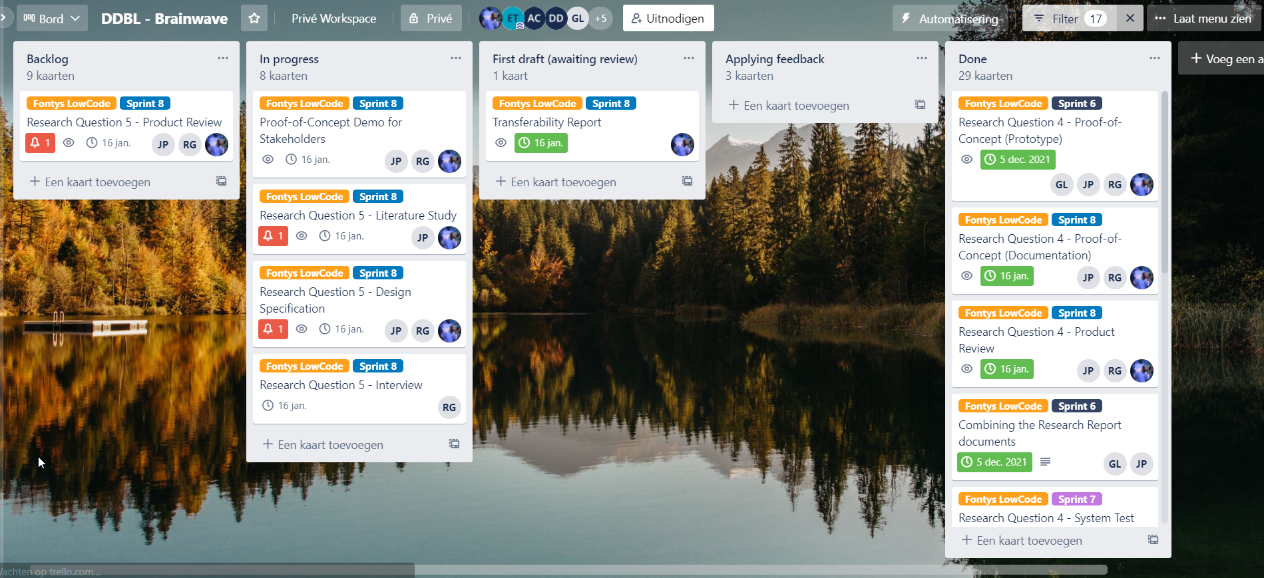

Figure 2: Example of the LowCode project in the Brainwave Trello

## Brainwave Advice

In the document ‘transferdocument LowCode’ is an advice stated for the next group that is going to work on this project. The following statements are an overview of this advice:

* Use Power Apps instead of the Microsoft Forms. Get into contact with Fontys IT (Flip Wetzer & Ron Limborgh) to enable and secure the environment of the Microsoft Power Platform to be able to work with Power Apps. When this is done properly, the following most important statements can be implemented:
  + Make Power Apps able to automatically fill in answers or give suggestion to certain questions according to the answers of previous filled in questions.
  + Make it able for Power Apps to make one forms in three sections (the three stages) and that the initiator can fill in the next section of questions when he gets approval by the certain stakeholders. This ensures that multiple questionnaires are not necessary. Culumative, keep the date when a project is requested and is when the certain sections are approved.
* Use Azure as a database instead of SharePoint lists. This will give a better security for the data that is collected. This will also lead to the data already been structured instead of using Power BI to structure the data.
* Within Power BI, improve or add graphs to the dashboards and make them drill-through, to be able to drill-through another level.
* Improve the questions within the forms and add descriptions for ‘difficult’ questions, so the initiator knows the meaning of all the questions that have been asked.
* Find out a way to connect the right person with the right function to a certain project using the stakeholder list.
* Make an instruction manual for the useability of the prototype. This will ultimately give a better user experience.