Process documentation Microsoft Power Automate

Brainwave
  - Author: Brainwave
Version:1.0
Date 23-12-2020

Contents
1. Introduction 2
1.1 Context 2
2.0 SharePoint list 3
2.1 LowCode list of current stakeholders 3
2.2 LowCode Project List. 4
3. Data Source Stage 1 8
4. Flow & Code 10
5. Data Source Stage 2 0
6. Flow & Code Stage 2 3
7.0 Flow & Code Stage 3 0
8. Flow & Code Power Power BI “Initiator overzicht 0
8. Flow & Code Power Power BI “Projecten Financieel Overzicht” 0
9. Flow & Code Power Power BI “Project Status Overzicht” 0
10. Flow & Code Power Power BI ‘Instituten Overzicht’ 0
11. User Test And Peer Review 0
11.1 User test 0
11.2 Peer Review 0
11.3 Results 0
11.4 Peer Review Feed Back 2

Introduction

This document introduces the reader to the Proof-Of-Concept (POC) of the ‘LowCode project’ created by Brainwave for Fontys. This POC is created within the Microsoft Power Automate to automate the project proposal phase and consist of three phases. The data gathered by forms and processed by Microsoft Power Automate will be used for creating dashboards with Power BI. This is further illustrated in figure 1, where a swim lane figure displays the flow of data.
This document further visualizes the flow within Microsoft Power Automate, along with visualization of the data sources and Power BI. Which are used for extensive test cases to create a more suitable automation.

1.1 Context
As mentioned in the introduction, Brainwave is using Microsoft Power Automate to automate the flow by using a Robotic Process Automation (RPA). This software was chosen due to PerusahaanIT’s previous research on the viability of the platform and the already available access by Fontys, due to the already established partnership with Microsoft.
This assignment is on selecting and implementing different solutions from the Microsoft Power Platform and creating a POC within this platform. This can then be used within the whole organization and the assignment and POC are combined into the same product.
The requirements of the POC are, creating an automatic flow within Microsoft Power Automate that helps the lecturer and other involved parties in the creation of a project proposal and visualize those within Power BI. There are several triggers causing the need of this POC. Like, automation a centralized storage of information and documents(for quick and easy access to those document instead of digging through teams, email or WhatsApp), an automated approval system(which is now done manually via email or in person), immediate information sending(which is now done manually and may miss some information by accident), limiting the possible document types (to have everyone use the same document type instead of different ones likes pdf, pages etc.) and database structured for dashboards(to provide additional overview of all projects).
The Tools used are Microsoft Forms. There are three different forms which all gather the required information for each stage of the project approval process. These forms trigger Microsoft Power Automate to gather the information of those forms and follow the created flow. This flow will then send information to SharePoint List. These lists are used as a database to store all the information gathered by these forms. This data is then used to create dashboards.
The above-mentioned triggers are current problems with the subsidiary project proposal system of Fontys. The POC needs to contain a solution for those triggers within the subsidiary project proposal system.

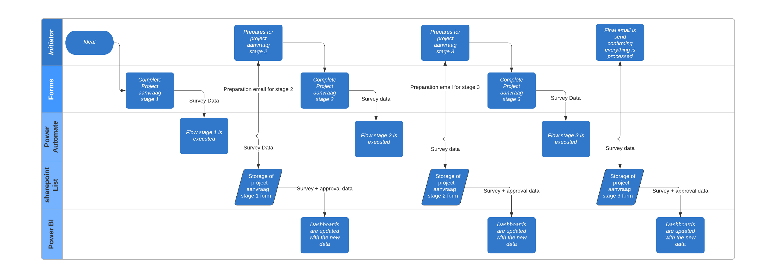
Figure 1 Swim Lane Data Flow

2.0 SharePoint list
This chapter visualizes the databases used by Brainwave for the POC, and the relationships between SharePoint list and other tools.

2.1 LowCode list of current stakeholders

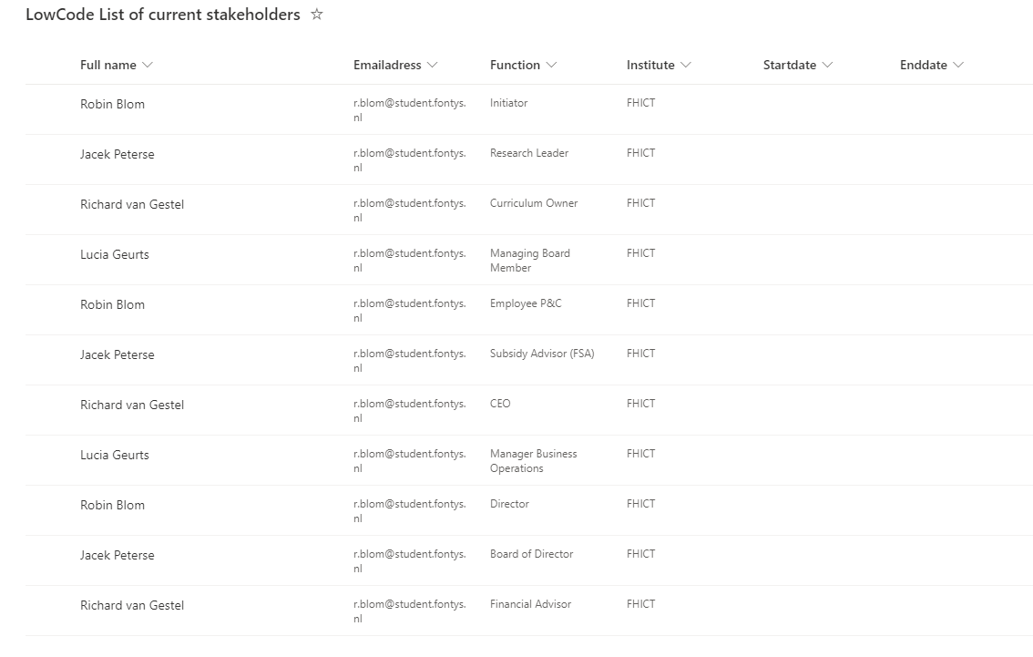
Figure 2 Stakeholders SharePoint List
Figure 1 displays the first SharePoint list Brainwave uses for this POC. It is a database containing stakeholders of the project proposals. The involvement of these roles is further explained in Research Report LowCode (2021). This data base is used to acquire the correct emails for approval and sending emails. This will be done by searching for the needed function along with the correct institute. Some functions and universal and will have “algemeen” in the institute row. The dates there to establish when employees will start and end employment, to correctly remove someone from the list. The process of adding and removing employees needs to be done manually.

Table 1 'LowCode List Of Current Stakeholders' Column type
Column Name | Data Type
Full name (first and last name) | Single line of text
Email address (Fontys email) | Single line of text
Function | Choice (all potential roles are already placed as an option
Institute | Single line of text
Start date (of employment) | Date
End date (of employment) | Date

2.2 LowCode Project List.

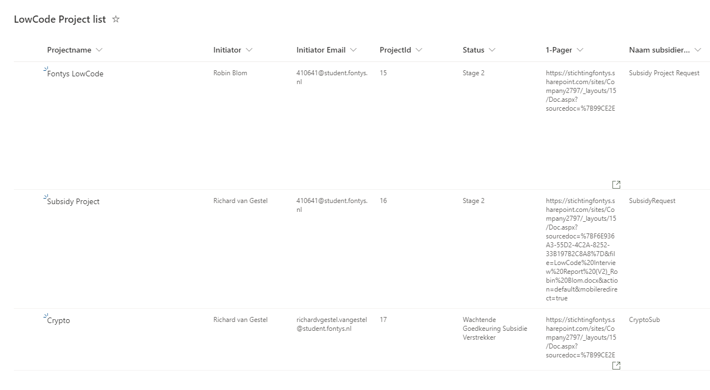
Figure 3 SharePoint List 'Low Code Project List’ Stage 1 Part 1/2
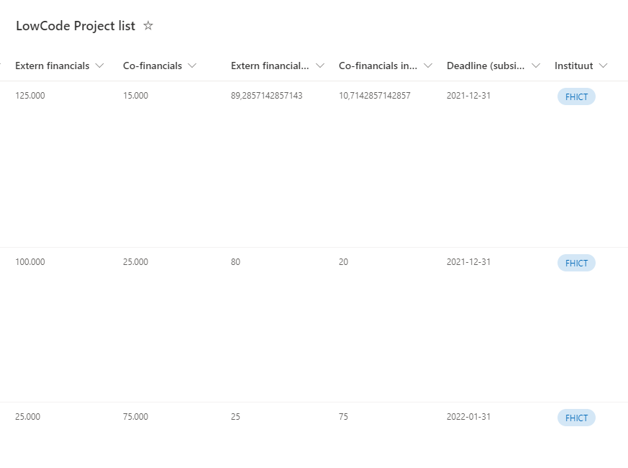
Figure 4 SharePoint list 'LowCode Project List' Stage 1 Part 2
Figures 2 and 3 display the database used for the first stage of the project. After a lecturer filling in the form “projectaanvraag (stage 1) “, a trigger Is sent to Microsoft Power automate which then stores the data in this SharePoint List from the form. The one pager link is used by Microsoft Power Automate as an attachment for validating the project proposal. The other information can always be extracted and used for again in later usages of Power Automate or for dashboarding with Power BI.

Table 2 Sharepoint List ‘LowCode Project List’ stage 1 Column type
Column Name | Data Type
Projectname | Single line of text
Initiator | Single line of text
Initiator Email | Single line of text
ProjectId | Number
Status | Choice
1-Pager | Multiple lines of text
Naam Subsidieverstrekker | Single line of text
Extern financials | Number
Co-financials | Number
External financials in % | Number
Co-financials in % | Number
Deadline (subsidy) request | Date
Instituut | Choice

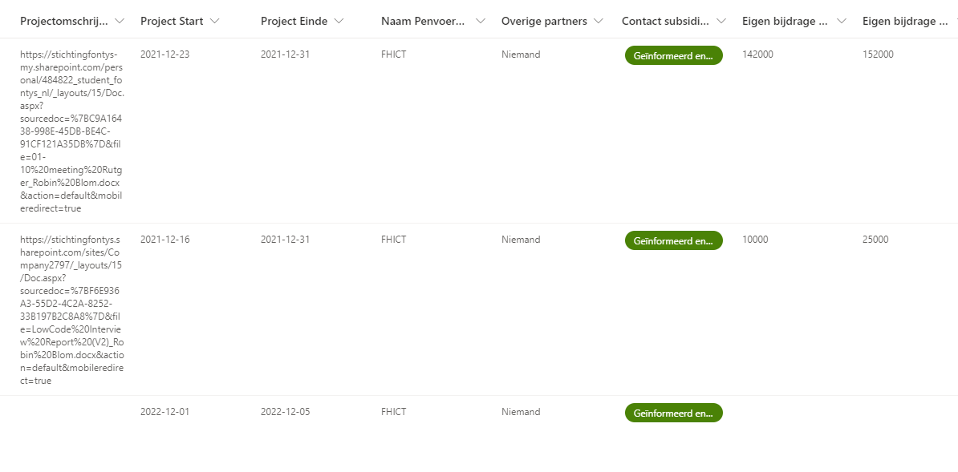
Figure 5 SharePoint list 'LowCode Project List' Stage 2 Part 1
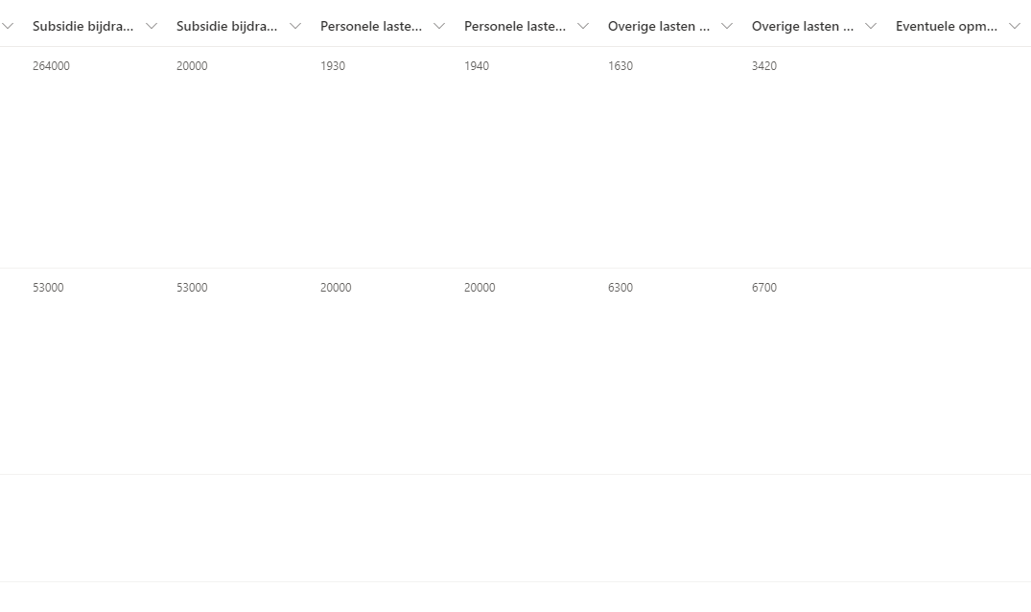
Figure 6 SharePoint list 'LowCode Project List' Stage 2 Part 2
Table 3 Sharepoint List ‘LowCode Project List’ stage 2 Column type
Column Name | Data Type
Projectomschrijving | Multiple lines of text
Project start | Date
Project einde | Date
Naam Penvoerende organisatie | Single line of text
Overige Partners | Single line of text
Contact subsidie adviseurs | Choice
Eigen bijdrage Fontys | Number
Eigen bijdrage partners | Number
Subsidie bijdrage Fontys | Number
Subsidie bijdrage partners | Number
Personele lasten Fontys | Number
Personele lasten partners | Number
Overige lasten Fontys | Number
Overige lasten partners | Number
Eventuele opmerkingen | Multiple lines of text

Figures 4 and 5 display the database used for the second stage of the project. The second stage starts when the lecturer fills the “projectaanvraag (stage 1)“ form. This is a trigger which is send to Microsoft Power automate which then stores the data in this SharePoint List from the form in the same row as in figure five and six. Making the information gather cumulative. The one pager link has now become a four pager which requestion additional information and is send by Power Automate as an attachment for validating the project proposal. The other information can always be extracted and used for again in later usages of Power Automate or for dashboarding with Power BI.

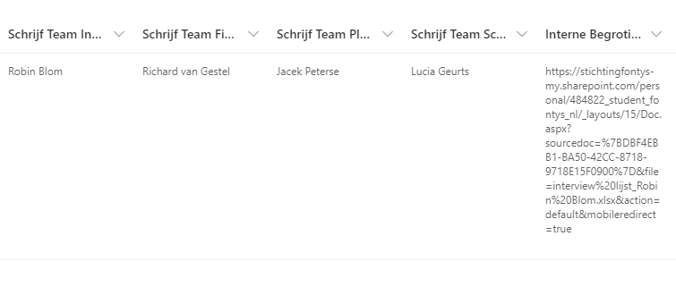
Figure 7 SharePoint list 'LowCode Project List' Stage 3
Table 4 Sharepoint List ‘LowCode Project List’ stage 3 Column type
Column Name | Data Type
Schijf team inhoudelijk | Single line of text
Schrijf team financieël | Single line of text
Schrijf team planning | Single line of text
Schrijf team Schrijver | Single line of text
Interne begroting | Multiple lines of text

Figure 6 displays the last database for the last stage. This form only requests the employees which have worked on the research proposal and for the internal budget document. This is a trigger which is send to Microsoft Power Automate which then stores the information from the form into SharePoint list. Instead of the one or four pagers, now the internal budget is requested and used as an attachment for approval. The other information can always be extracted and used for again in later usages of Power Automate or for dashboarding with Power BI.

2.3 Centre Of Expertise.

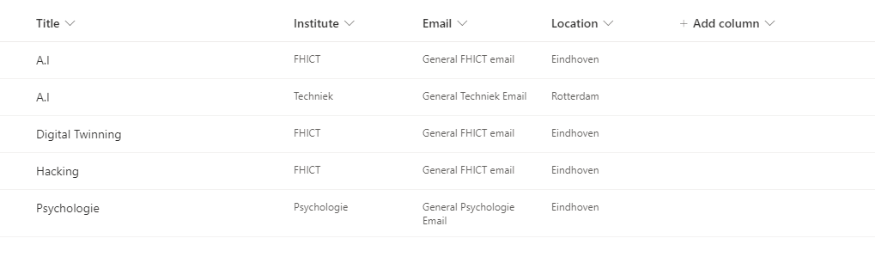
Figure 8 Centre Of Expertise
Column Name | Data Type
Title | Single line of text
Institute | Choice
Email | Single line of text
Location | Choice

Figure 8 displays the centre of expertise SharePoint List. This list is meant to Contain all centre of expertise within Fontys. This concept is in works and not officially out. The goal of these centres to allow the possibility for employees to easily search and get in touch with an expertise. Each institute will have multiple expertise and each expertise can have multiple institutes. This data is further used in a dashboard.

3. Relationship Model Power BI
This chapter introduces and elobarted the relationship model used within Power Bi, this chapter uses the previous SharePoint lists and some additional data sources. To prepare for chapter 9, 10 and 11 where the flow and code is elaborated.

The Proof-Of-Concept in Power BI uses several data sources. The LowCodeProjectList, LowCodeListOfcurrentStakeholders and Centre Of Expertise has been previously elaborated on in chapter 2. Brainwave decided to add additional data sources to ensure the SharePoint List data can be displayed appropriately. Firstly the Dim_Institute consist of two institutes which are then linked to both the SharePoint List. Secondly, the Dim_Date, consist of all days of the year. This is used in order to create a measure which checks the current date compared to all the project, this is then linked to the dates of the LowCodeProjectList. These measures are elaborated on in chapter 9, 10 and 11.

Thirdly the Measure table, these are the measures which calculate different data. These measures use the outcomes of the Dim_Date and LowCodeProjectList to determine how many projects are in which stage. Lastely, Centre Of Expertise’s data is also used to display

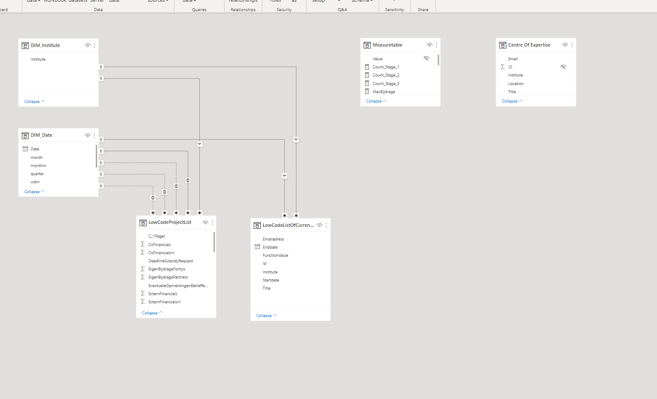
Figure 9 Relationship Model Power Bi Proof-Of-Concept

4. Data Source Stage 1
For this flow a different data sources are used. This chapter further illustrates those data sources along with the relationship to the other tools.
Form “Projectaanvraag (Stage 1)”

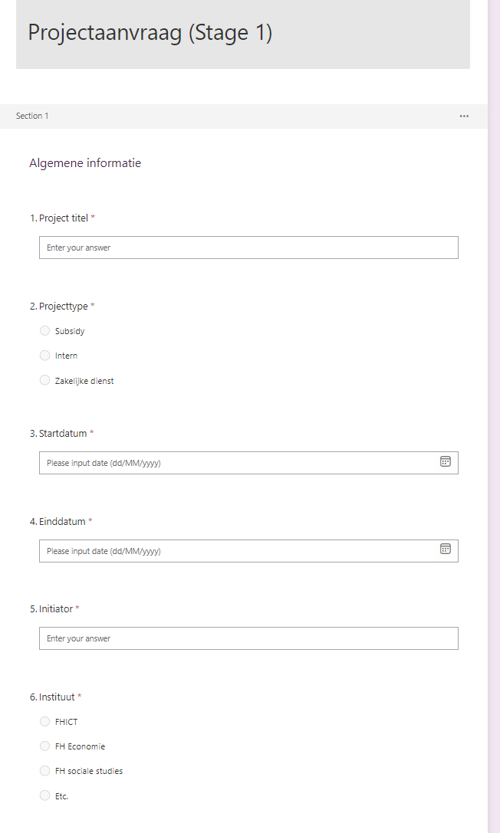
Figure 10 form ‘Projectaanvraag (Stage 1)’ section 1/3
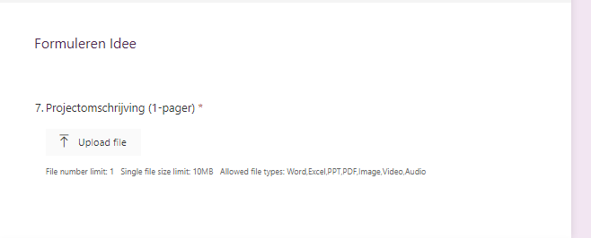
Figure 11 form ‘Projectaanvraag (Stage 1)’ section 2/3

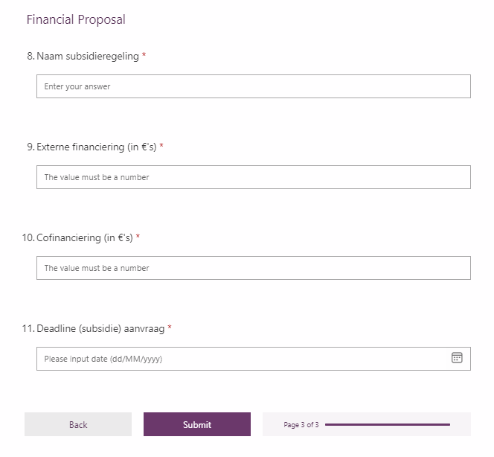
Figure 12 form ‘Projectaanvraag (Stage 1)’ section 2/3
Link: https://forms.office.com/r/kKBMT8u1QQ

Figures 7, 8, and 9 are the first project proposal forms. This form is separates in three sections which all require different information. The first form requires basic information on what the project, who starts the project, 1 page document with more information on the project for approval and some financial information. Once the form is filled in, it will trigger a flow in Microsoft Power Automate.

5. Flow & Code

This chapter will visualize and explain the flow created for stage 1 out of 3 by Brainwave within Microsoft Power Automate. This flow contains 21 steps, all steps and code are displayed in table 10

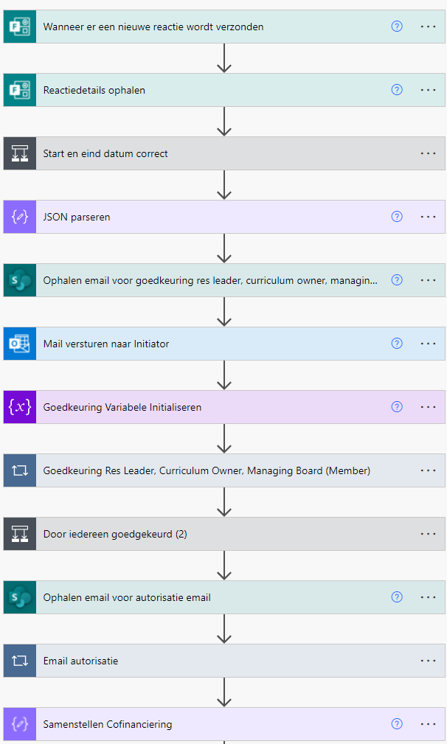
Figure 13Microsoft Power Automate Flow Stage 1 1/2

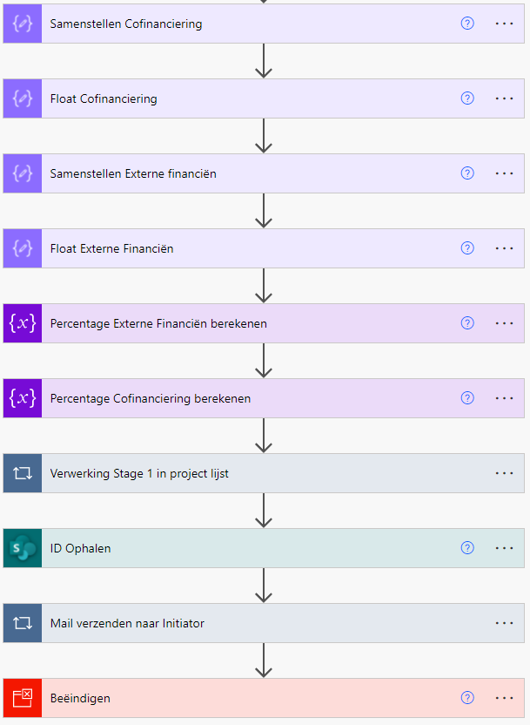
Figure 14 Microsoft Power Automate Flow Stage 1 2/2

Step | Explanation | Code
1 | 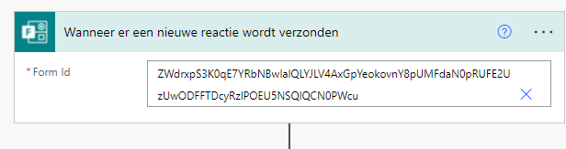  This first step is the trigger for the flow. It starts when “Project Aanvraag Stage 1” in forms is filled in. | {  "inputs": {  "host": {  "connectionName": "shared_microsoftforms",  "operationId": "CreateFormWebhook",  "apiId": "/providers/Microsoft.PowerApps/apis/shared_microsoftforms"  },  "parameters": {  "form_id": "ZWdrxpS3K0qE7YRbNBwIalQLYJLV4AxGpYeokovnY8pUMFdaN0pRUFE2UzUwODFFTDcyRzlPOEU5NSQlQCN0PWcu"  },  "authentication": "@parameters('$authentication')"  },  "metadata": {  "operationMetadataId": "15e7a127-6dfb-4723-a7cd-565b8fbeccf8"  },  "splitOn": "@triggerOutputs()?['body/value']"  }
2 | 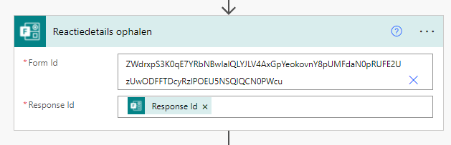  This step will the extract the data from the “Aanvraag Formulier Stage 1” form. | {  "inputs": {  "host": {  "connectionName": "shared_microsoftforms",  "operationId": "GetFormResponseById",  "apiId": "/providers/Microsoft.PowerApps/apis/shared_microsoftforms"  },  "parameters": {  "form_id": "ZWdrxpS3K0qE7YRbNBwIalQLYJLV4AxGpYeokovnY8pUMFdaN0pRUFE2UzUwODFFTDcyRzlPOEU5NSQlQCN0PWcu",  "response_id": "@triggerOutputs()?['body/resourceData/responseId']"  },  "authentication": "@parameters('$authentication')"  },  "metadata": {  "operationMetadataId": "74e25dda-3c27-4679-87c6-922c2f34d762"  }  }
3 | 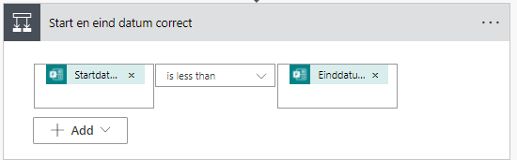 | -
3.1A | 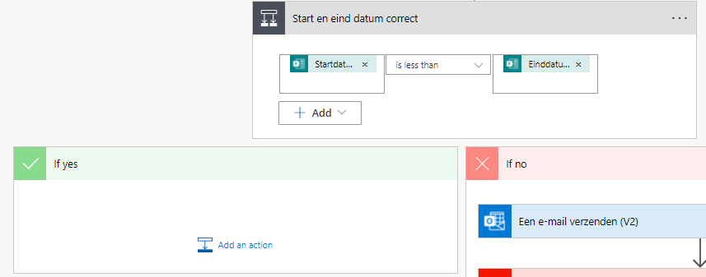  The flow checks if the filled in form start date is sooner then the end date.
3.1B | 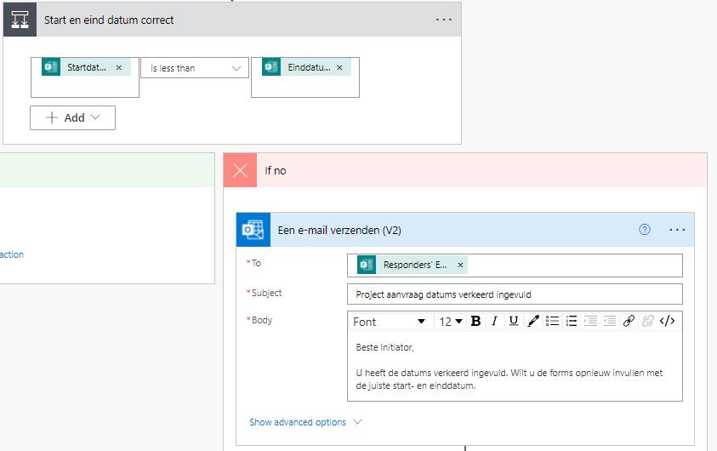  If the end date is sooner then the start date, then an email is send to the responder informing them of their mistake. | {  "inputs": {  "host": {  "connectionName": "shared_office365_1",  "operationId": "SendEmailV2",  "apiId": "/providers/Microsoft.PowerApps/apis/shared_office365"  },  "parameters": {  "emailMessage/To": "@outputs('Reactiedetails_ophalen')?['body/responder']",  "emailMessage/Subject": "Project aanvraag datums verkeerd ingevuld",  "emailMessage/Body": "<p>Beste Initiator,<br>\n<br>\nU heeft de datums verkeerd ingevuld. Wilt u de forms opnieuw invullen met de juiste start- en einddatum.</p>"  },  "authentication": "@parameters('$authentication')"  },  "metadata": {  "operationMetadataId": "238d7c9e-6268-4ae5-a628-73aeaa94099e"  }  }
3.2B | 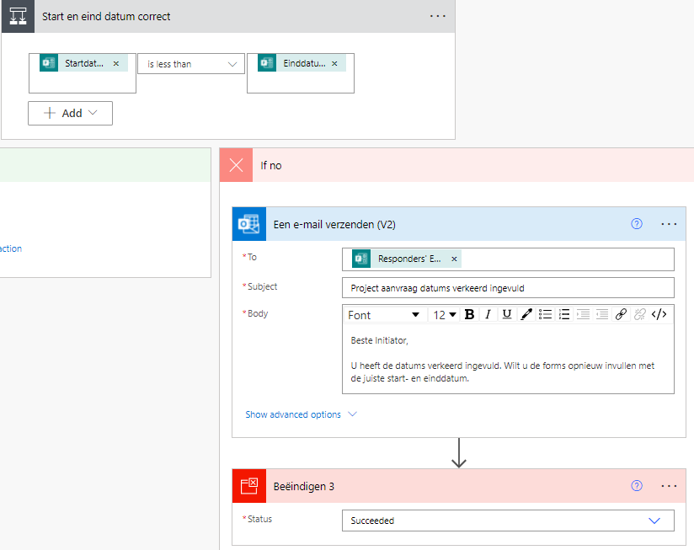  The flow is then ended. | {  "metadata": {  "operationMetadataId": "131b4319-35bf-421e-9f31-e6b472e7c721"  },  "inputs": {  "runStatus": "Succeeded"  }  }
4 | 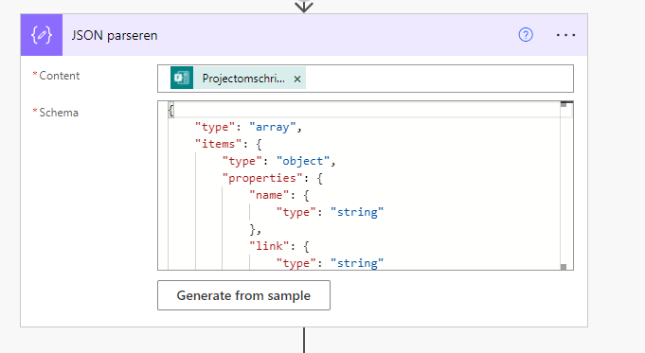  In this step Json separate all the variables of the project omschrijving document (one pager) which come from the document. These are the following:  -Name  -Link  -ID  -ReferenceId  -Driveld  -Size  -Status  Instead of a whole string containing all these variables breaking the hyperlink when used in other stages. | {  "inputs": {  "content": "@outputs('Reactiedetails_ophalen')?['body/r88615898378c4778b25846e33bc371e2']",  "schema": {  "type": "array",  "items": {  "type": "object",  "properties": {  "name": {  "type": "string"  },  "link": {  "type": "string"  },  "id": {  "type": "string"  },  "type": {},  "size": {  "type": "integer"  },  "referenceId": {  "type": "string"  },  "driveId": {  "type": "string"  },  "status": {  "type": "integer"  },  "uploadSessionUrl": {}  },  "required": [  "name",  "link",  "id",  "type",  "size",  "referenceId",  "driveId",  "status",  "uploadSessionUrl"  ]  }  }  },  "metadata": {  "operationMetadataId": "bebea787-f2fc-421f-9435-8a75f8088ce5"  }  }
5 | 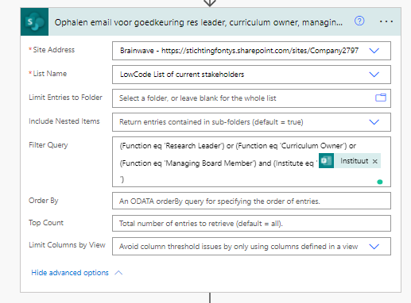  This step gathers emailadresses of the functions Research Leader, Curriculum Owner and Managing Board Member. These emailadresses are gathered from the “LowCode List Of Current Stakeholders”. These emailadresses are filted on function and institute which the lecturer has answered in the form “Aanvraag Fomrulier Stage 1”. | {  "inputs": {  "host": {  "connectionName": "shared_sharepointonline",  "operationId": "GetItems",  "apiId": "/providers/Microsoft.PowerApps/apis/shared_sharepointonline"  },  "parameters": {  "dataset": "https://stichtingfontys.sharepoint.com/sites/Company2797",  "table": "71bde792-7934-4bd6-92cd-2321c90cf55b",  "$filter": "(Function eq 'Research Leader') or (Function eq 'Curriculum Owner') or (Function eq 'Managing Board Member') and (Institute eq '@{outputs('Reactiedetails_ophalen')?['body/r51684c3a6fab4e2ca15b1ca5e32ef4d2']}')"  },  "authentication": "@parameters('$authentication')"  },  "metadata": {  "operationMetadataId": "60504765-3ee6-4660-8d36-046a0aad3c7b"  }  }
6 | 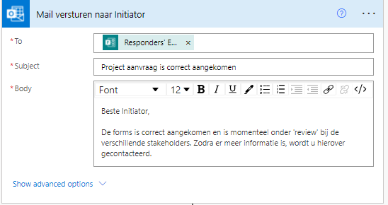  This step sends an email to the responder, notifying them that their forms has succesfully been received. | {  "inputs": {  "host": {  "connectionName": "shared_office365_1",  "operationId": "SendEmailV2",  "apiId": "/providers/Microsoft.PowerApps/apis/shared_office365"  },  "parameters": {  "emailMessage/To": "@outputs('Reactiedetails_ophalen')?['body/responder']",  "emailMessage/Subject": "Project aanvraag is correct aangekomen",  "emailMessage/Body": "<p>Beste Initiator,<br>\n<br>\nDe forms is correct aangekomen en is momenteel onder 'review' bij de verschillende stakeholders. Zodra er meer informatie is, wordt u hierover gecontacteerd.</p>"  },  "authentication": "@parameters('$authentication')"  },  "metadata": {  "operationMetadataId": "2451f631-f187-458c-8db3-d9a1cc8ad715"  }
7 | 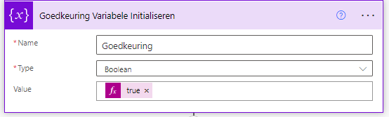  This step sets a variable to true. This is due to step 8 not having the option for a condition action | {  "inputs": {  "variables": [  {  "name": "Goedkeuring",  "type": "boolean",  "value": "@true"  }  ]  },  "metadata": {  "operationMetadataId": "7c009df0-d1b2-451c-9917-bce8d6f4494e"  }  }
8 | 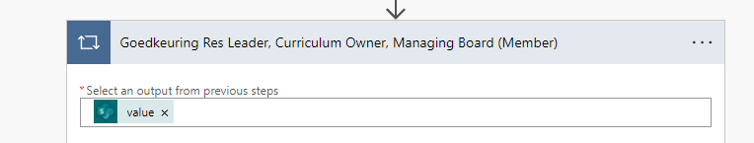  This step takes the emailadresses from step four, by selecting the output. These emailadresses are used in step 8.2 | {  "inputs": {  "host": {  "connectionName": "shared_approvals",  "operationId": "StartAndWaitForAnApproval",  "apiId": "/providers/Microsoft.PowerApps/apis/shared_approvals"  },  "parameters": {  "approvalType": "BasicAwaitAll",  "WebhookApprovalCreationInput/title": "@outputs('Reactiedetails_ophalen')?['body/rb4e7d32cfd804599b7efb54173724bae']",  "WebhookApprovalCreationInput/assignedTo": "@items('Goedkeuring_Res_Leader,_Curriculum_Owner,_Managing_Board_(Member)')?['Emailadress']",  "WebhookApprovalCreationInput/itemLink": "@items('Op_elk(e)_toepassen')['link']",  "WebhookApprovalCreationInput/itemLinkDescription": "Beste @{items('Goedkeuring_Res_Leader,_Curriculum_Owner,_Managing_Board_(Member)')?['Title']},\n\nGaat u akkoord met deze project aanvraag?",  "WebhookApprovalCreationInput/enableNotifications": true,  "WebhookApprovalCreationInput/enableReassignment": true  },  "authentication": "@parameters('$authentication')"  },  "metadata": {  "operationMetadataId": "ace32a8c-a5d9-49e0-9c51-592325356e48"  }  }
8.1 | 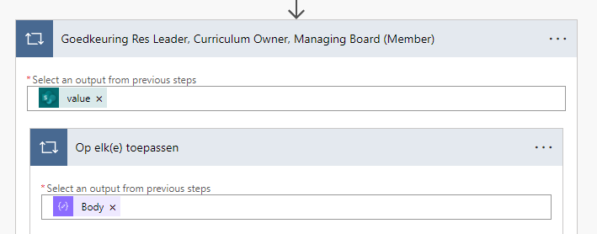  This step takes the Json variables from step three, and enables the usage of all variables in step 8.2.
8.2 | 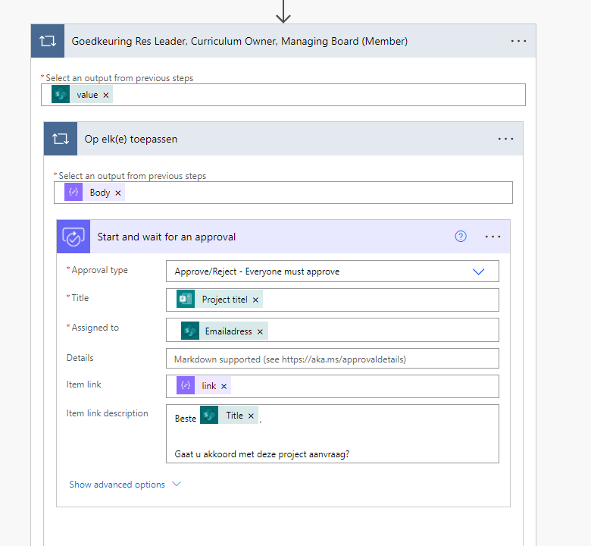  This step starts the approvals for the Employee P&C, CEO and Manager Business Operations. It send an email to these function which are gathered from step 5. This email contains an approval or deniel option, the title of the project and the new attachment from the new form “Projectomschrijving (1 pager)”. The Employee P&C, CEO and Manager Business Operations Must all approve the project in order for it to continue. If any of them denies this proposal then the initiator will receive the feedback given by set employee and the flow ends.
8.3A | 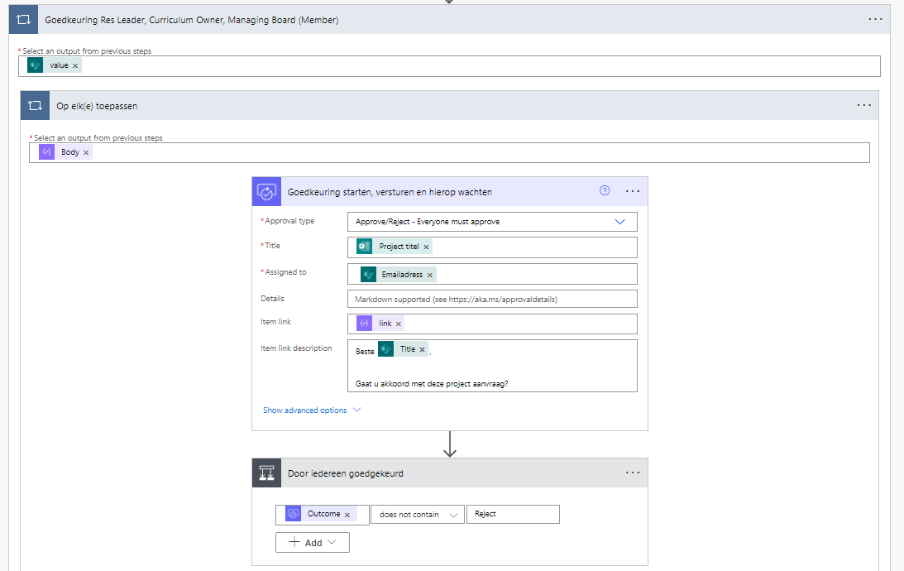  If all all the employees approve the projects then the answere is yes and nothing changes. If one or more employees rejects this then the flow goes to no.
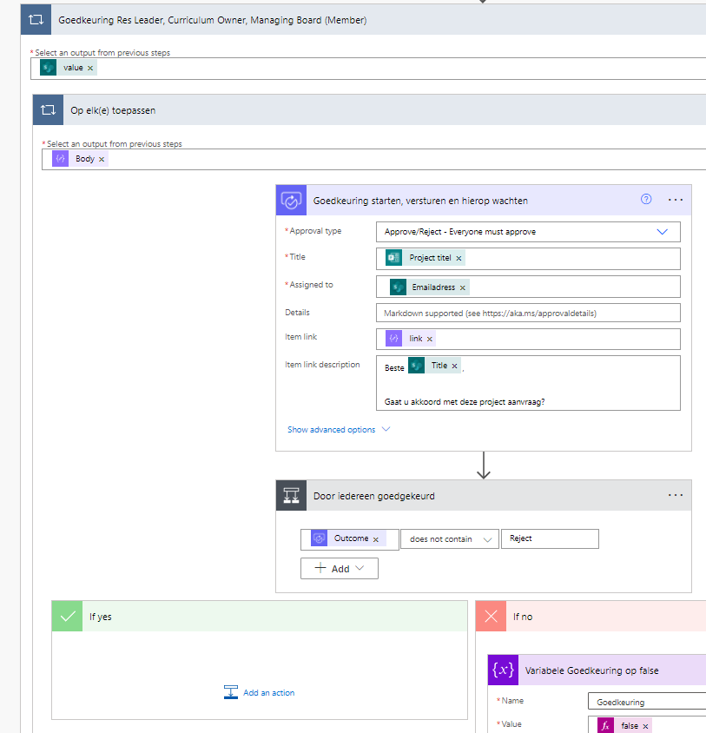
If everyone has approved the project, then the flow goes to ‘yes’ and continues forwards
8.3B | 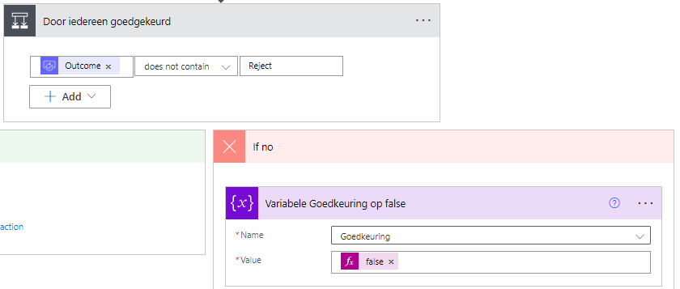  If one of the employees rejects the proposal, then the variable in 7 gets changed from ‘true’ to ‘false’ | {  "inputs": {  "name": "Goedkeuring",  "value": "@false"  },  "metadata": {  "operationMetadataId": "ad78ce81-ec12-43c7-a677-d30f589d8909"  }  }
9 | 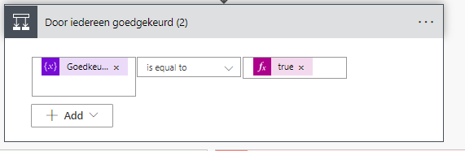  This step looks if the variable is still true or false. If true it goes to yes if false then it goes to no.
9.1A | 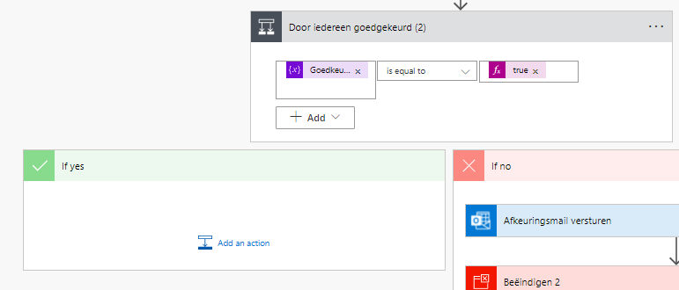  If the answer is true the flow will continue
9.1B | 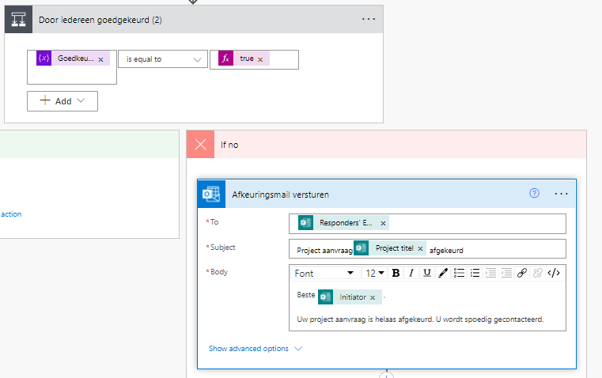  An email will be send to the responder informing them that the project has been rejected. | {  "inputs": {  "host": {  "connectionName": "shared_office365_1",  "operationId": "SendEmailV2",  "apiId": "/providers/Microsoft.PowerApps/apis/shared_office365"  },  "parameters": {  "emailMessage/To": "@outputs('Reactiedetails_ophalen')?['body/responder']",  "emailMessage/Subject": "Project aanvraag@{outputs('Reactiedetails_ophalen')?['body/rb4e7d32cfd804599b7efb54173724bae']} afgekeurd",  "emailMessage/Body": "<p>Beste @{outputs('Reactiedetails_ophalen')?['body/r6fcfbef85b8f4976b32ccae47c59934f']},<br>\n<br>\nUw project aanvraag is helaas afgekeurd. U wordt spoedig gecontacteerd.</p>"  },  "authentication": "@parameters('$authentication')"  },  "metadata": {  "operationMetadataId": "8af0b40c-5967-49c0-8d08-c3effb92ca96"  }  }
9.2B | 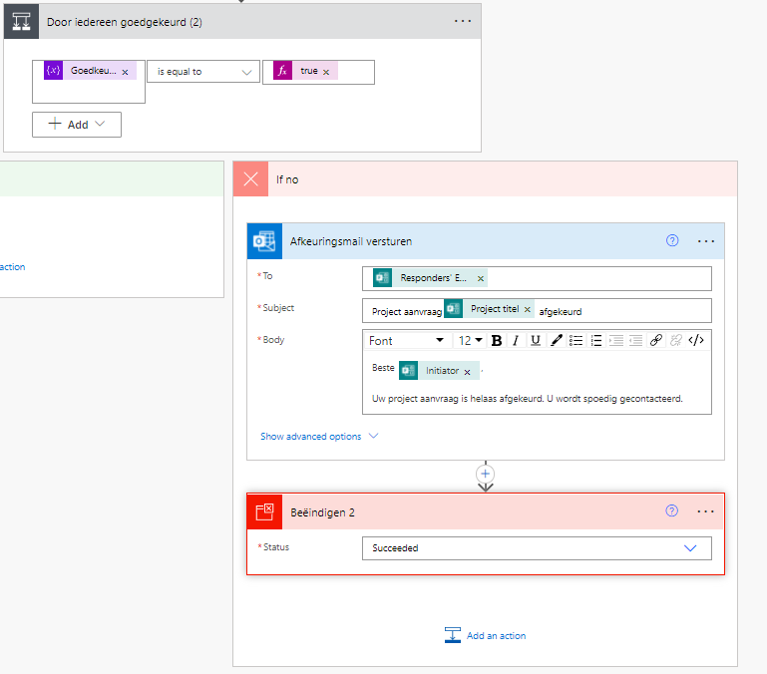  This step end the flow. | {  "metadata": {  "operationMetadataId": "cd97f248-6bd6-4cbd-87fb-dc32d1d16971"  },  "inputs": {  "runStatus": "Succeeded"  }  }
10 | 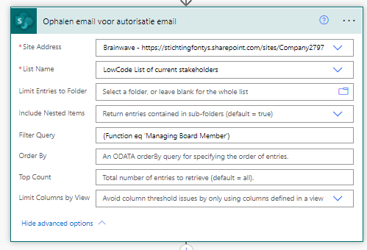  This step gathers emailadresses of the Managing Board Member, from the SharePoint list “LowCode List Of Current Stakeholders”. These emailadresses are filted on function. | {  "inputs": {  "host": {  "connectionName": "shared_sharepointonline",  "operationId": "GetItems",  "apiId": "/providers/Microsoft.PowerApps/apis/shared_sharepointonline"  },  "parameters": {  "dataset": "https://stichtingfontys.sharepoint.com/sites/Company2797",  "table": "71bde792-7934-4bd6-92cd-2321c90cf55b",  "$filter": "(Function eq 'Managing Board Member')"  },  "authentication": "@parameters('$authentication')"  },  "metadata": {  "operationMetadataId": "8ac42bc6-8c9a-4711-8a64-cfd84c83afb7"  }  }
11 | 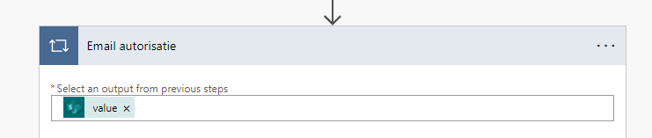  This step takes the emailadresses from step six, by selecting the output. These emailadresses are used in step 7.2 | {  "inputs": {  "host": {  "connectionName": "shared_office365",  "operationId": "SendEmailV2",  "apiId": "/providers/Microsoft.PowerApps/apis/shared_office365"  },  "parameters": {  "emailMessage/To": "@items('Email_autorisatie_')?['Emailadress']",  "emailMessage/Subject": "Project autorisatie @{outputs('Reactiedetails_ophalen')?['body/rb4e7d32cfd804599b7efb54173724bae']}",  "emailMessage/Body": "<p>Geachte heer/mevrouw,<br>\n<br>\nEr is zojuist een project aanvraag gestart door @{outputs('Reactiedetails_ophalen')?['body/r6fcfbef85b8f4976b32ccae47c59934f']} van het instituut @{items('Email_autorisatie_')?['Institute']}.<br>\n<br>\nHierbij de link naar het document:<br>\n<br>\n@{items('Op_elk(e)_toepassen_2')['link']}<br>\n<br>\nGelieve aan de hand van dit document akkoord of geen akkoord geven.<br>\n<br>\nFontys Hogescholen<br>\n</p>"  },  "authentication": "@parameters('$authentication')"  },  "metadata": {  "operationMetadataId": "00a2161c-a9e1-41ac-9724-6d3e95e1f2a6"  }  }
11.1 | 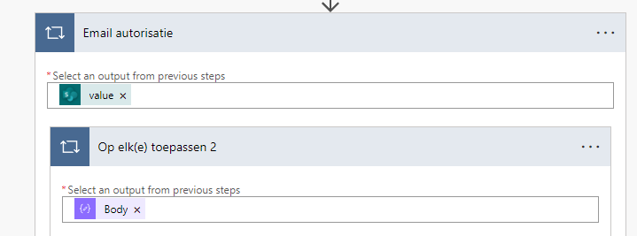  This step takes the Json variables from step three, and enables the usage of all variables in step 7.2
11.2 | 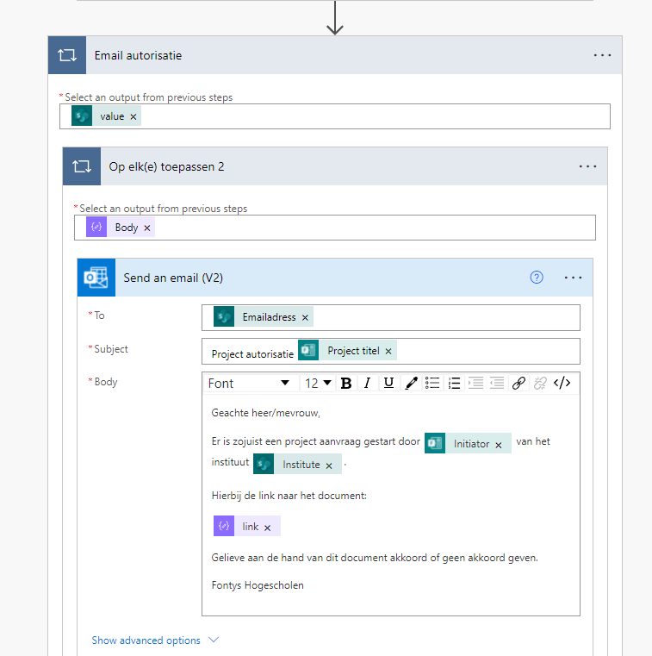  This step sends an email to the “Managing Board Member” containing the autorisation of the project. As all employees from five have approved the project. So now the project can be authorized. By the Managing Board, for this the link to the “Project omschrijving (1 pager) is send again along with the project title and initiators name.  The emailadress is gather from step 7.1. Project title, initiator and institute are all gather from the forms in step 2 and the link for the “Project omschrijving (1 pager)” is the Json link gather from 7.1.
12 | 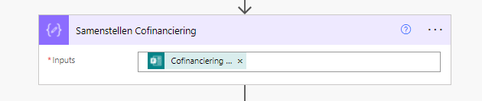  This step extracts the input of ‘cofinanciering | {  "inputs": "@outputs('Reactiedetails_ophalen')?['body/rc898e8f4b7c147069732b0582a4efdec']",  "metadata": {  "operationMetadataId": "6459d376-89c6-4ed2-a38d-a655d7523411"  }  }
13 | 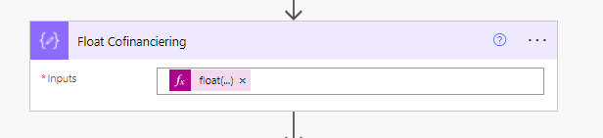  This step translates the previous input into a float | {  "inputs": "@float(outputs('Samenstellen_Cofinanciering'))",  "metadata": {  "operationMetadataId": "9772c61d-4a1b-4961-86de-18cf8c0dadc9"  }  }
14 | 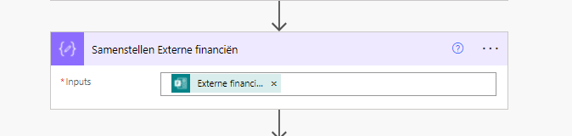  This step extracts the input of ‘Externe Financiën’ | {  "inputs": "@outputs('Reactiedetails_ophalen')?['body/r05b2a5f41381419a8788ed2adeda77cb']",  "metadata": {  "operationMetadataId": "83006748-5fb6-42b6-9728-451b03aa962d"  }  }
15 | 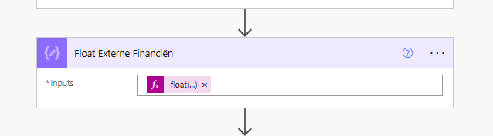  This step transaltes the previous input into a float | {  "inputs": "@float(outputs('Samenstellen_Externe_financiën'))",  "metadata": {  "operationMetadataId": "a9d7bf6c-c05d-4fe0-b33d-18a8d9829d49"  }  }
16 | 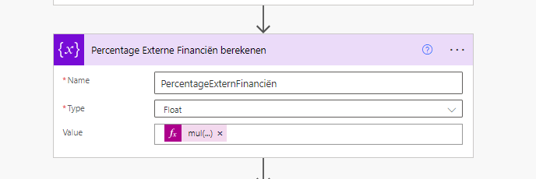  This step calculates the percentage of the amount of external financing | {{  "inputs": {  "variables": [  {  "name": "PercentageExternFinanciën",  "type": "float",  "value": "@mul(div(outputs('Float_Externe_Financiën'),add(outputs('Float_Externe_Financiën'),outputs('Float_Cofinanciering'))),100)"  }  ]  },  "metadata": {  "operationMetadataId": "d6bd95df-b2ee-4ad7-934a-e1f8918bb506"  }  }
17 | 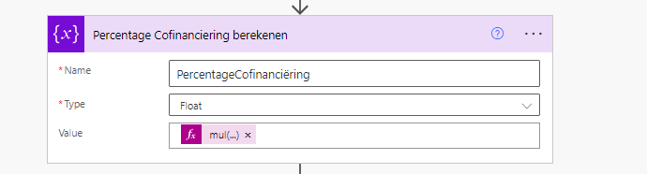  This step calculates the percentage of the amount of cofinancing | {  "inputs": {  "variables": [  {  "name": "PercentageCofinanciëring",  "type": "float",  "value": "@mul(div(outputs('Float_Cofinanciering'),add(outputs('Float_Externe_Financiën'),outputs('Float_Cofinanciering'))),100)"  }  ]  },  "metadata": {  "operationMetadataId": "f671284e-c20a-4b65-9c6d-c1f7cee04dc7"  }  }
18 | 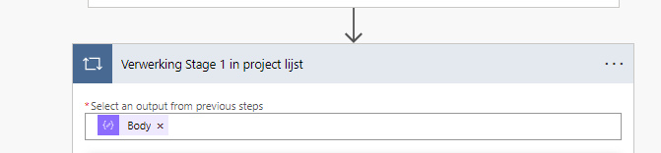  This step takes the Json variables from step 3, and enables the usage of all variables in step 18.1 | {  "inputs": {  "host": {  "connectionName": "shared_sharepointonline_1",  "operationId": "PostItem",  "apiId": "/providers/Microsoft.PowerApps/apis/shared_sharepointonline"  },  "parameters": {  "dataset": "https://stichtingfontys.sharepoint.com/sites/Company2797",  "table": "7fc526fe-a48a-4dd2-a2fa-283b564af813",  "item/Title": "@outputs('Reactiedetails_ophalen')?['body/rb4e7d32cfd804599b7efb54173724bae']",  "item/Initiator": "@outputs('Reactiedetails_ophalen')?['body/r6fcfbef85b8f4976b32ccae47c59934f']",  "item/InitiatorEmail": "@outputs('Reactiedetails_ophalen')?['body/responder']",  "item/ProjectId": "@triggerOutputs()?['body/resourceData/responseId']",  "item/Status/Value": "Stage 1",  "item/OData__x0031__x002d_Pager": "@items('Verwerking_Stage_1_in_project_lijst')['link']",  "item/Naamsubsidieregeling": "@outputs('Reactiedetails_ophalen')?['body/r166c50c408924ce59d54d945f7bf6552']",  "item/Externfinancials": "@outputs('Reactiedetails_ophalen')?['body/r05b2a5f41381419a8788ed2adeda77cb']",  "item/Co_x002d_financials": "@outputs('Reactiedetails_ophalen')?['body/rc898e8f4b7c147069732b0582a4efdec']",  "item/Externfinancialsin_x0025_": "@variables('PercentageExternFinanciën')",  "item/Co_x002d_financialsin_x0025_": "@variables('PercentageCofinanciëring')",  "item/Deadline_x0028_subsidy_x0029_req": "@outputs('Reactiedetails_ophalen')?['body/r53e8ae9822304a89853a1a51e726cdb9']",  "item/Instituut/Value": "@outputs('Reactiedetails_ophalen')?['body/r51684c3a6fab4e2ca15b1ca5e32ef4d2']",  "item/Projectstart": "@outputs('Reactiedetails_ophalen')?['body/r389f6e1574a544d29f9759abd056053b']",  "item/ProjectEinde": "@outputs('Reactiedetails_ophalen')?['body/r239a9b3e164f4dd3a20d9c578687d535']",  "item/Projecttype/Value": "@outputs('Reactiedetails_ophalen')?['body/r6e46c9ab59804e9cb316481d036334d6']"  },  "authentication": "@parameters('$authentication')"  },  "metadata": {  "operationMetadataId": "7edbe3ba-e190-4c2c-bab8-80ca06d8f29e"  }  }
18.1 | 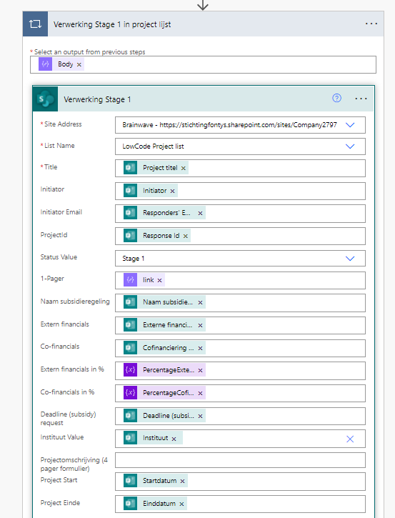  This step takes all the answeres from the froms and creates a new row in “LowCode Project List” database. which then adds the values from the form. Along with the status “Stage 1”  The following values are added to the database :  -Project title  -Initiator  -Initiator Email  -ProjectId  -Stage 1  -HTTML link to the “project omschrijving (1pager) document”  -Name subsidy scheme  -External financials  -Co-Financials  -External financials in %  -Co-Financials in %  -Deadline (subsidy request)  -Institute  -Project start date  -Project end date
19 | 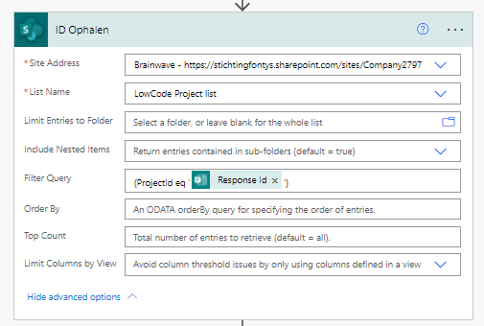  This step gathers the Project Id from the SharePoint list “LowCode Project List”. This Project Id is automatically assigned to the project once a new row is created by step 14.1. This Project Id is used for step 16 | {  "inputs": {  "host": {  "connectionName": "shared_sharepointonline_1",  "operationId": "PostItem",  "apiId": "/providers/Microsoft.PowerApps/apis/shared_sharepointonline"  },  "parameters": {  "dataset": "https://stichtingfontys.sharepoint.com/sites/Company2797",  "table": "7fc526fe-a48a-4dd2-a2fa-283b564af813",  "item/Title": "@outputs('Reactiedetails_ophalen')?['body/rb4e7d32cfd804599b7efb54173724bae']",  "item/Initiator": "@outputs('Reactiedetails_ophalen')?['body/r6fcfbef85b8f4976b32ccae47c59934f']",  "item/InitiatorEmail": "@outputs('Reactiedetails_ophalen')?['body/responder']",  "item/ProjectId": "@triggerOutputs()?['body/resourceData/responseId']",  "item/Status/Value": "Stage 1",  "item/OData__x0031__x002d_Pager": "@items('Verwerking_Stage_1_in_project_lijst')['link']",  "item/Naamsubsidieregeling": "@outputs('Reactiedetails_ophalen')?['body/r166c50c408924ce59d54d945f7bf6552']",  "item/Externfinancials": "@outputs('Reactiedetails_ophalen')?['body/r05b2a5f41381419a8788ed2adeda77cb']",  "item/Co_x002d_financials": "@outputs('Reactiedetails_ophalen')?['body/rc898e8f4b7c147069732b0582a4efdec']",  "item/Externfinancialsin_x0025_": "@variables('PercentageExternFinanciën')",  "item/Co_x002d_financialsin_x0025_": "@variables('PercentageCofinanciëring')",  "item/Deadline_x0028_subsidy_x0029_req": "@outputs('Reactiedetails_ophalen')?['body/r53e8ae9822304a89853a1a51e726cdb9']",  "item/Instituut/Value": "@outputs('Reactiedetails_ophalen')?['body/r51684c3a6fab4e2ca15b1ca5e32ef4d2']",  "item/Projectstart": "@outputs('Reactiedetails_ophalen')?['body/r389f6e1574a544d29f9759abd056053b']",  "item/ProjectEinde": "@outputs('Reactiedetails_ophalen')?['body/r239a9b3e164f4dd3a20d9c578687d535']",  "item/Projecttype/Value": "@outputs('Reactiedetails_ophalen')?['body/r6e46c9ab59804e9cb316481d036334d6']"  },  "authentication": "@parameters('$authentication')"  },  "metadata": {  "operationMetadataId": "7edbe3ba-e190-4c2c-bab8-80ca06d8f29e"  }  }
20 | 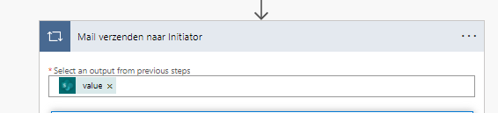  This step gathers the Project Id from step 19. Which allows it to be used for step 20.1. | {  "inputs": {  "host": {  "connectionName": "shared_office365_1",  "operationId": "SendEmailV2",  "apiId": "/providers/Microsoft.PowerApps/apis/shared_office365"  },  "parameters": {  "emailMessage/To": "@outputs('Reactiedetails_ophalen')?['body/responder']",  "emailMessage/Subject": "Stage 1 Project aanvraag (@{outputs('Reactiedetails_ophalen')?['body/rb4e7d32cfd804599b7efb54173724bae']}) is afgerond",  "emailMessage/Body": "<p>Geachte @{outputs('Reactiedetails_ophalen')?['body/r6fcfbef85b8f4976b32ccae47c59934f']},<br>\n<br>\nBedankt voor het invullen van uw project aanvraag: &nbsp;@{outputs('Reactiedetails_ophalen')?['body/rb4e7d32cfd804599b7efb54173724bae']}.<br>\n<br>\nDeze is door de Research leader, curriculum owner en de managing board member goedgekeurd.<br>\n<br>\nU kunt nu over naar stage 2. Dit houdt in dat er diepere informatie gevraagd wordt over het project met de volgende onderwerpen:<br>\n<br>\n- Project omschrijving (4 pagina's)<br>\n- Project start datum<br>\n- Project eind datum<br>\n- Pen voerende organisatie<br>\n- Overige partners<br>\n- Concept begroting met een marge van 10%<br>\n&nbsp;&nbsp;&nbsp;&nbsp;&nbsp;&nbsp;&nbsp;- Eigen bijdrage Fontys &amp; partners<br>\n&nbsp;&nbsp;&nbsp;&nbsp;&nbsp;&nbsp;&nbsp;- Subsidie verleend aan Fontys &amp; partners<br>\n&nbsp;&nbsp;&nbsp;&nbsp;&nbsp;&nbsp;&nbsp;- Personele lasten Fontys &amp; partners<br>\n&nbsp;&nbsp;&nbsp;&nbsp;&nbsp;&nbsp;&nbsp;- Overige lasten Fontys &amp; partners<br>\n<br>\nOm stage 2 te beginnen moet u het zojuist genoemde formulier aan de hand van deze link invullen: https://forms.office.com/r/zAtgKTvwnf<br>\nMet als id nummer @{items('Mail_verzenden_naar_Initiator')?['ProjectId']}.<br>\n<br>\nVoor extra advies kunt u altijd bij de subsidie adviseurs terecht (insert email). Deze zullen u helpen bij het proces van de aanvraag en eventuele verdere vragen over subsidies.<br>\n<br>\nMet vriendelijke groet,<br>\n<br>\nFontys Hogescholen</p>"  },  "authentication": "@parameters('$authentication')"  },  "metadata": {  "operationMetadataId": "09bcdc6e-a121-412c-9941-0653bcfcfc8c"  }  }
20.1 | 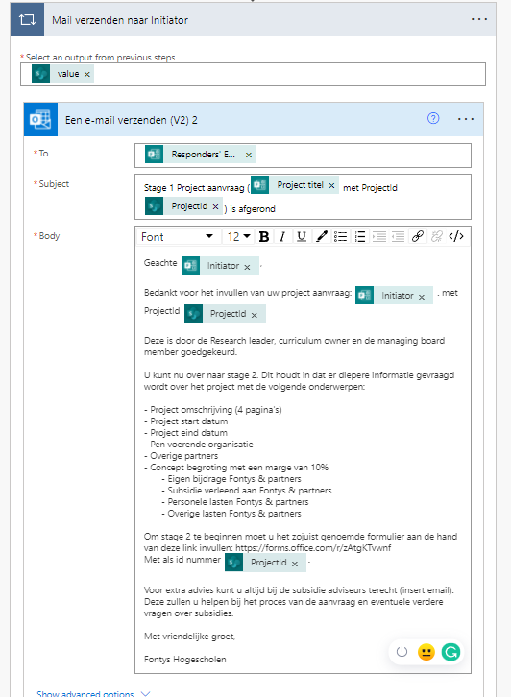  This step send the initiator an email. This email confirms that the the project has been approved by the Research Leader, Curriculm Owner and the Managing Board. It then provides a list of questions asked in the next form “Projectaanvraag (Stage2) , and a link to the new form with the ProjectId gathered from 16.0 which is required in this POC in order to link form 2 and 3 to the correct row in SharePoint list “LowCode Project List”. The email finishes with recomendations and the email adress of the subsidy advisors.
21 | 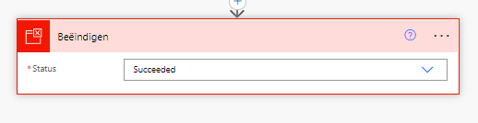  This step ends the flow so that it cannot be stuk in an infinate loop. | {  "metadata": {  "operationMetadataId": "2d451d43-8b76-4353-9e53-13dea8194be1"  },  "inputs": {  "runStatus": "Succeeded"  }  }

6. Data Source Stage 2

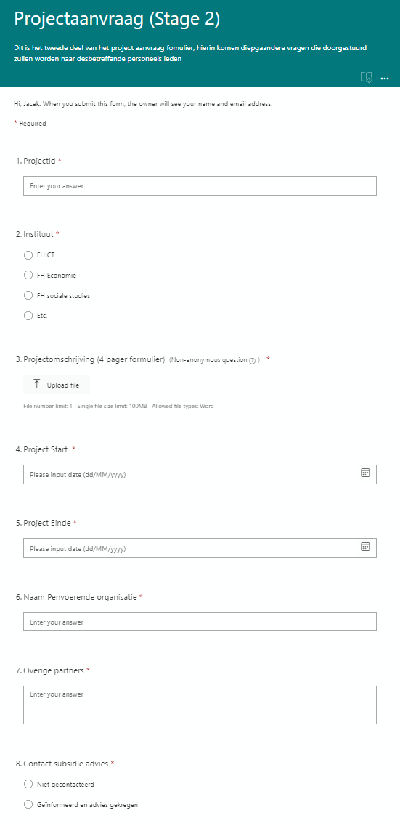
Figure 15 form ‘Projectaanvraag (Stage 2)’ section 1/3

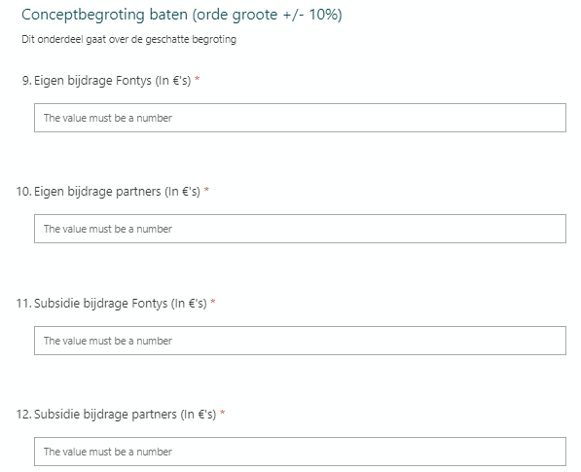
Figure 16 form ‘Projectaanvraag (Stage 2)’ section 2/3
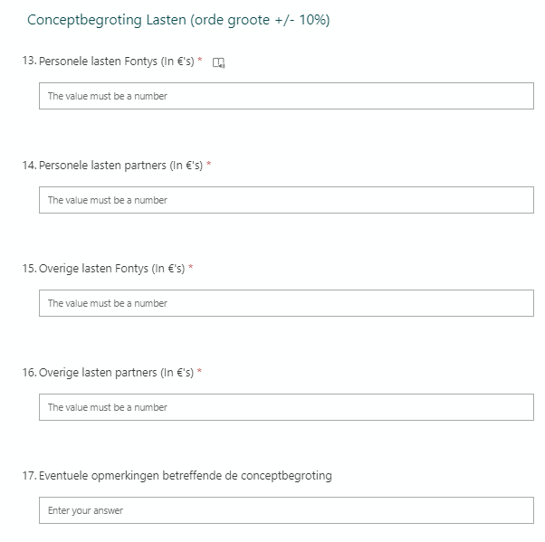

Figure 17 form ‘Projectaanvraag (Stage 2)’ section 3/3
Link: https://forms.office.com/r/zAtgKTvwnf

Figures 12, 13 and 14 are the second project proposal form. This form is separates in three sections which all require different information. The first section required the ProjectId to ensure power automate can connect this to the correct row in the SharePoint list “LowCode Project List”, and an attachment “project omschrijving (4 pager formulier) which contains more elaborate information about the project. And then some administration information. Section two asks to give a ballpark estimate of 10% to budget incoming funds and section three asks to budget the expenses in a ballpark of 10%. Once the form is filled in, it will trigger a flow in Microsoft Power Automate.

7. Flow & Code Stage 2

This chapter will visualize and explain the flow created for stage 2 out of 3 by Brainwave within Microsoft Power Automate. This flow contains 14 steps, all steps and code are displayed in table 15
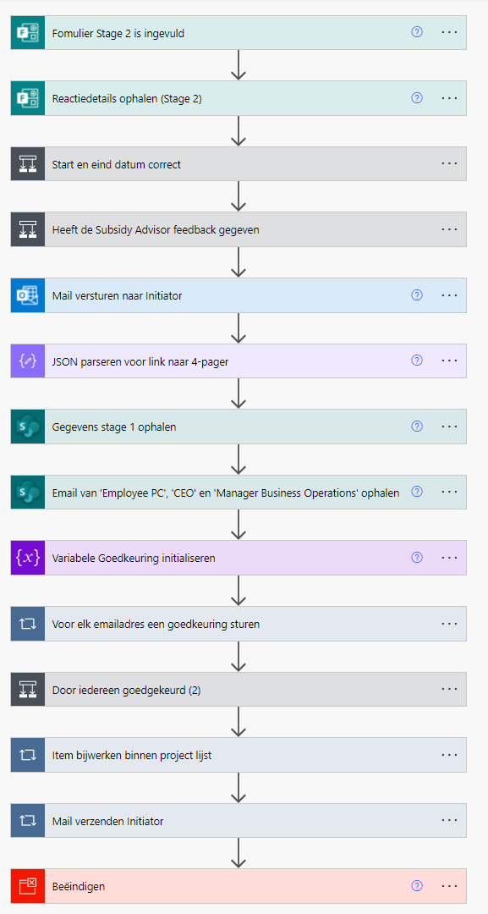
Figure 18 Microsoft Power Automate Flow Stage 2
tep | Explanation | Code
1 | 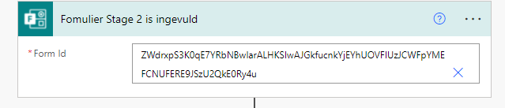  This first step is the trigger for the flow. It starts when “Project Aanvraag Stage 2” in forms is filled in. | {  "inputs": {  "host": {  "connectionName": "shared_microsoftforms",  "operationId": "CreateFormWebhook",  "apiId": "/providers/Microsoft.PowerApps/apis/shared_microsoftforms"  },  "parameters": {  "form_id": "ZWdrxpS3K0qE7YRbNBwIarALHKSIwAJGkfucnkYjEYhUOVFIUzJCWFpYMEFCNUFERE9JSzU2QkE0Ry4u"  },  "authentication": "@parameters('$authentication')"  },  "metadata": {  "operationMetadataId": "15e7a127-6dfb-4723-a7cd-565b8fbeccf8"  },  "splitOn": "@triggerOutputs()?['body/value']"  }
2 | 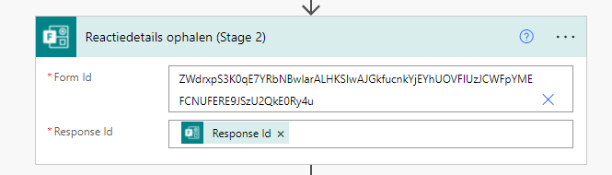  This step will the extract the data from the “Aanvraag Fomrulier Stage 2” form. | {  "inputs": {  "host": {  "connectionName": "shared_microsoftforms",  "operationId": "GetFormResponseById",  "apiId": "/providers/Microsoft.PowerApps/apis/shared_microsoftforms"  },  "parameters": {  "form_id": "ZWdrxpS3K0qE7YRbNBwIarALHKSIwAJGkfucnkYjEYhUOVFIUzJCWFpYMEFCNUFERE9JSzU2QkE0Ry4u",  "response_id": "@triggerOutputs()?['body/resourceData/responseId']"  },  "authentication": "@parameters('$authentication')"  },  "metadata": {  "operationMetadataId": "74e25dda-3c27-4679-87c6-922c2f34d762"  }  }
3 | 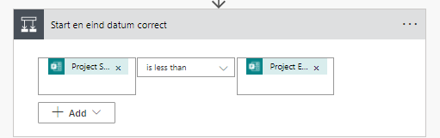  This step looks is the project start data is before project end date. If this is true then it goes to yes, if not it goes to no
3.1A | 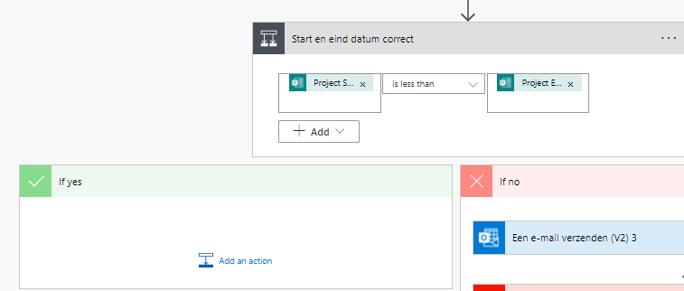  This step is a yes and the flow continuous
3.1B | 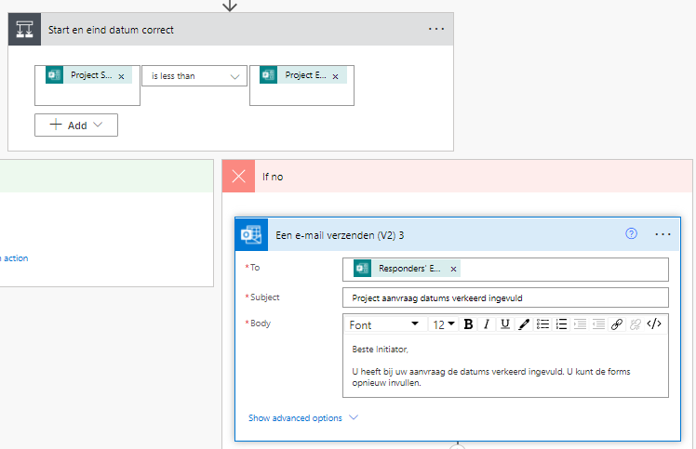  In this step an email gets send to the initiator stating that there has been a mistake and the date should be adjusted. | {  "inputs": {  "host": {  "connectionName": "shared_office365",  "operationId": "SendEmailV2",  "apiId": "/providers/Microsoft.PowerApps/apis/shared_office365"  },  "parameters": {  "emailMessage/To": "@outputs('Reactiedetails_ophalen_(Stage_2)')?['body/responder']",  "emailMessage/Subject": "Project aanvraag datums verkeerd ingevuld",  "emailMessage/Body": "<p>Beste Initiator,<br>\n<br>\nU heeft bij uw aanvraag de datums verkeerd ingevuld. U kunt de forms opnieuw invullen.</p>"  },  "authentication": "@parameters('$authentication')"  },  "metadata": {  "operationMetadataId": "efe98d9b-c4ac-445e-bb9a-ce54a90e6263"  }  }
3.2B | 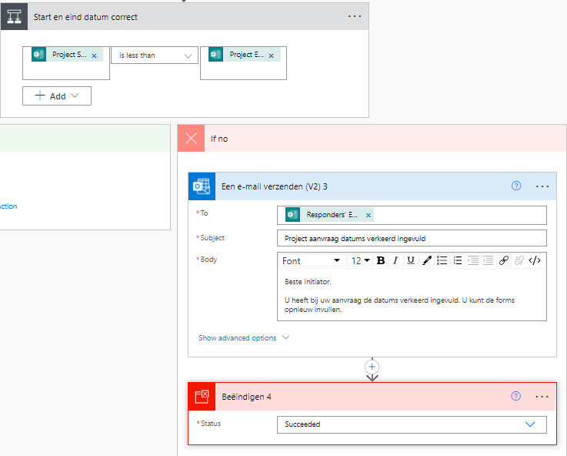  This step then ends the flow | {  "metadata": {  "operationMetadataId": "d0008eb5-5596-41e7-8d2e-b4ed003b9575"  },  "inputs": {  "runStatus": "Succeeded"  }  }
4 | 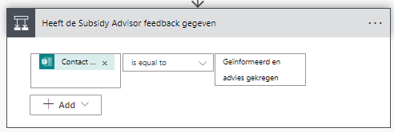  In this step Power Automate looks at the data gather from the “Projectaanvraag (Stage 2)”, which asks if the subsidy advisors have been informed and have given advice. If this is “true” then the flow proceeds to step 3.1A. If this has not happened then the answer is “false” and then the flow goes to step 3.1B
4.1 A | 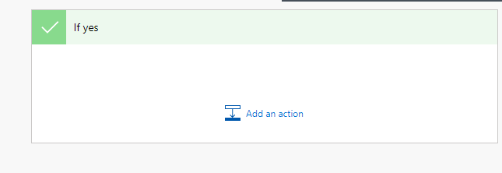  The subsidy advisors have been informed and gave advice, so the flow advances to step 4
4.1 B | 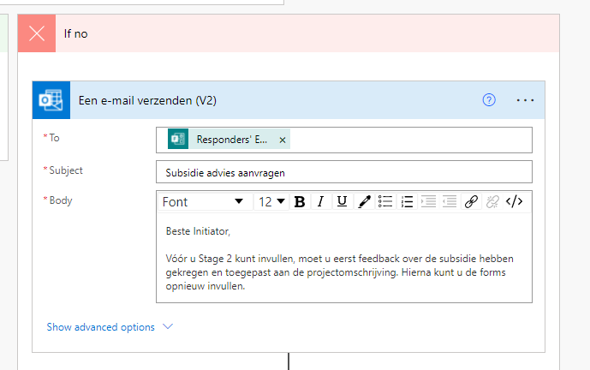  This step sends an email to the responder of the form. This email states that in order to proceed with stage 2 the responder first needs to inform the subsidy advisors. After receiving feedback the initiator may redo the form again. | {  "inputs": {  "host": {  "connectionName": "shared_office365",  "operationId": "SendEmailV2",  "apiId": "/providers/Microsoft.PowerApps/apis/shared_office365"  },  "parameters": {  "emailMessage/To": "@outputs('Reactiedetails_ophalen_(Stage_2)')?['body/responder']",  "emailMessage/Subject": "Subsidie advies aanvragen",  "emailMessage/Body": "<p>Beste Initiator,<br>\n<br>\nVóór u Stage 2 kunt invullen, moet u eerst feedback over de subsidie hebben gekregen en toegepast aan de projectomschrijving. Hierna kunt u de forms opnieuw invullen.</p>"  },  "authentication": "@parameters('$authentication')"  },  "metadata": {  "operationMetadataId": "8b534c73-3dea-4aad-92ef-e3b3efe29dbe"  }  }
4.2 B | 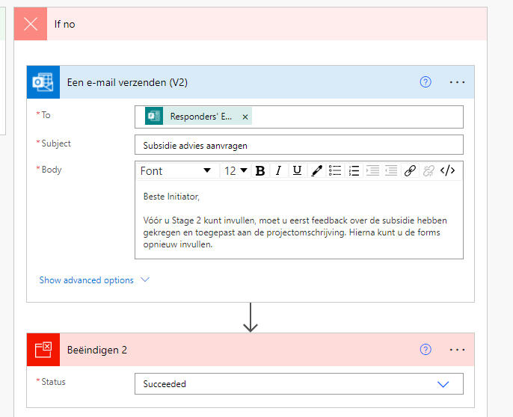  The flow is being stopped in step, as it cannot continue until the subsidy advisors have been informed. | {  "metadata": {  "operationMetadataId": "29827af1-48b8-4ffe-91a9-dca171e03ac4"  },  "inputs": {  "runStatus": "Succeeded"  }  }  }
5 | 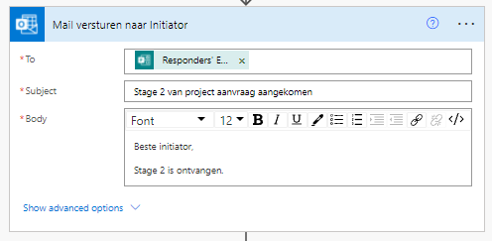  This step sends an email to the responder, notifying them that their forms has succesfully been received. | {  "inputs": {  "host": {  "connectionName": "shared_office365",  "operationId": "SendEmailV2",  "apiId": "/providers/Microsoft.PowerApps/apis/shared_office365"  },  "parameters": {  "emailMessage/To": "@outputs('Reactiedetails_ophalen_(Stage_2)')?['body/responder']",  "emailMessage/Subject": "Stage 2 van project aanvraag aangekomen",  "emailMessage/Body": "<p>Beste initiator,<br>\n<br>\nStage 2 is ontvangen.</p>"  },  "authentication": "@parameters('$authentication')"  },  "metadata": {  "operationMetadataId": "2b24f751-9ba8-45b7-b418-678154a07429"  }  }
6 | 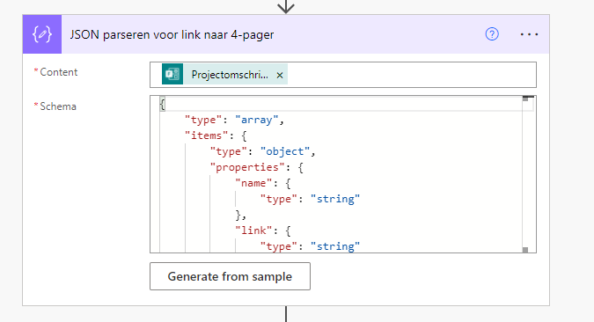  In this step Json separate all the variables of the “Project Omschrijving (4 pager formulier) which come from the document. These are the following:  -Name  -Link  -ID  -ReferenceId  -Driveld  -Size  -Status  Instead of a whole string containing all these variables breaking the hyperlink when used in other stages. | {  "inputs": {  "content": "@outputs('Reactiedetails_ophalen_(Stage_2)')?['body/r82339bf2639240ba91973bae6f489326']",  "schema": {  "type": "array",  "items": {  "type": "object",  "properties": {  "name": {  "type": "string"  },  "link": {  "type": "string"  },  "id": {  "type": "string"  },  "type": {},  "size": {  "type": "integer"  },  "referenceId": {  "type": "string"  },  "driveId": {  "type": "string"  },  "status": {  "type": "integer"  },  "uploadSessionUrl": {}  },  "required": [  "name",  "link",  "id",  "type",  "size",  "referenceId",  "driveId",  "status",  "uploadSessionUrl"  ]  }  }  },  "metadata": {  "operationMetadataId": "bebea787-f2fc-421f-9435-8a75f8088ce5"  }  }
7 | 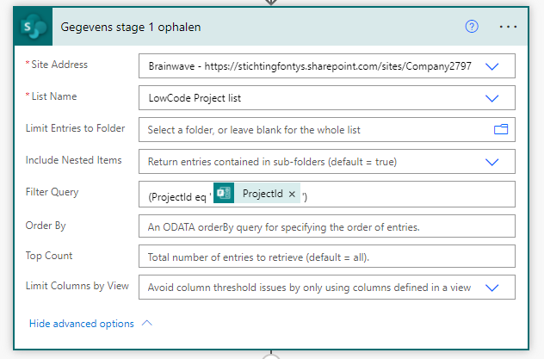  This step gathers the row created by the first stage of forms and Microsoft Power automate from the SharePoint list “LowCode Project List”. This is done by using the ProjectId gather by forms and using this as a filter in the SharePoint List. | {  "inputs": {  "host": {  "connectionName": "shared_sharepointonline_1",  "operationId": "GetItems",  "apiId": "/providers/Microsoft.PowerApps/apis/shared_sharepointonline"  },  "parameters": {  "dataset": "https://stichtingfontys.sharepoint.com/sites/Company2797",  "table": "7fc526fe-a48a-4dd2-a2fa-283b564af813",  "$filter": "(ProjectId eq '@{outputs('Reactiedetails_ophalen_(Stage_2)')?['body/r01902fa9abf143e594d5fdece2ed1287']}')"  },  "authentication": "@parameters('$authentication')"  },  "metadata": {  "operationMetadataId": "11ab2f47-9987-4b1b-b222-d81b71604b11"  }  }
8 | 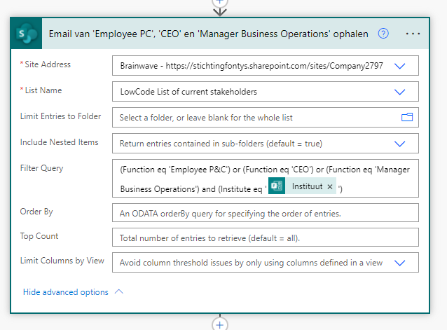  This step gathers emailadresses of the functions: Employee P&C, Ceo andManager business Operations. These emailadresses are gathered from the “LowCode List Of Current Stakeholders”. These emailadresses are filted on function and institute which the lecturer has answered in the form “Aanvraag Fomrulier Stage 2”. | {  "inputs": {  "host": {  "connectionName": "shared_sharepointonline",  "operationId": "GetItems",  "apiId": "/providers/Microsoft.PowerApps/apis/shared_sharepointonline"  },  "parameters": {  "dataset": "https://stichtingfontys.sharepoint.com/sites/Company2797",  "table": "71bde792-7934-4bd6-92cd-2321c90cf55b",  "$filter": "(Function eq 'Employee P&C') or (Function eq 'CEO') or (Function eq 'Manager Business Operations') and (Institute eq '@{outputs('Reactiedetails_ophalen_(Stage_2)')?['body/r8729efe4b30a412e98c10b48b5012084']}')"  },  "authentication": "@parameters('$authentication')"  },  "metadata": {  "operationMetadataId": "90252152-b965-4588-8fd2-5407bbd62193"  }  }
9 | 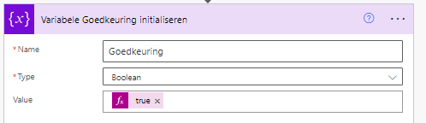  This step sets a variable to true. This is due to step 10 not having the option for a condition action | {  "inputs": {  "variables": [  {  "name": "Goedkeuring",  "type": "boolean",  "value": "@true"  }  ]  },  "metadata": {  "operationMetadataId": "7c009df0-d1b2-451c-9917-bce8d6f4494e"  }
10 | 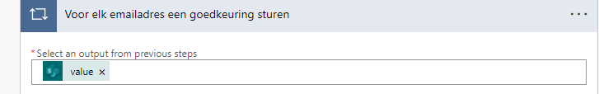  This step takes the emailadresses from step 6, by selecting the output. These emailadresses are used in step 7.3
10.1 | 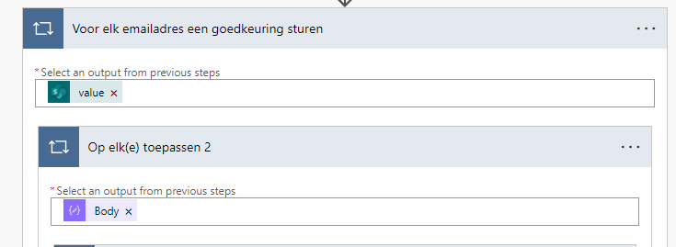  This step takes the Json variables from step 4, and enables the usage of all variables in step 7.3
10.2 | 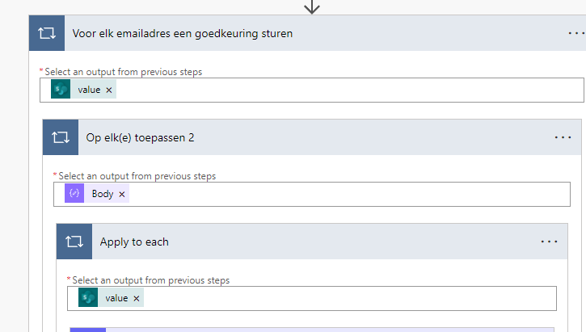  This step takes all the previous acquired project information, which is received from step 5. This enables 7.3 to use all the information from the database.
10.3 | 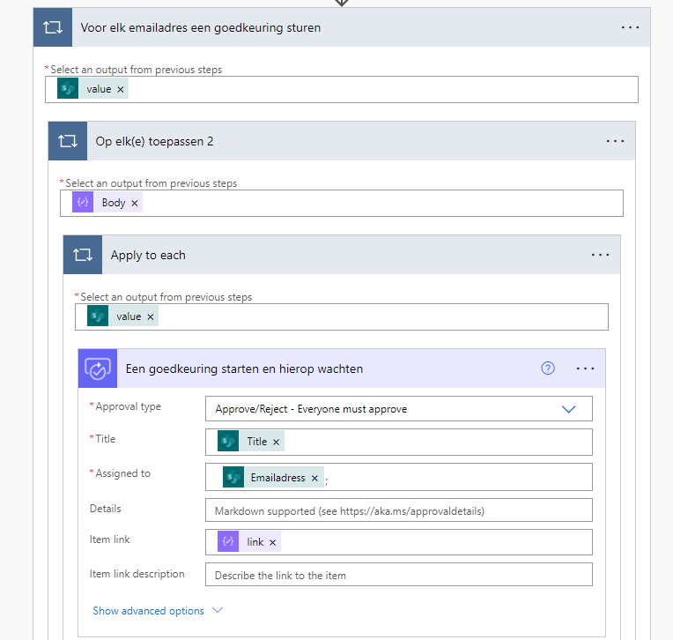  This step starts the approvals for the Employee P&C, CEO and Manager Business Operations. It send an email to these function which are gathered from step 7. This email contains an approval or deniel option, the title of the project and the new attachment from the new form “Projectomschrijving (4 pager formulier)”. The Employee P&C, CEO and Manager Business Operations Must all approve the project in order for it to continue. If any of them denies this proposal then the initiator will receive the feedback given by set employee and the flow ends. | {  "inputs": {  "host": {  "connectionName": "shared_approvals",  "operationId": "StartAndWaitForAnApproval",  "apiId": "/providers/Microsoft.PowerApps/apis/shared_approvals"  },  "parameters": {  "approvalType": "BasicAwaitAll",  "WebhookApprovalCreationInput/title": "@items('Apply_to_each')?['Title']",  "WebhookApprovalCreationInput/assignedTo": "@{items('Voor_elk_emailadres_een_goedkeuring_sturen')?['Emailadress']};",  "WebhookApprovalCreationInput/itemLink": "@items('Op_elk(e)_toepassen_2')['link']",  "WebhookApprovalCreationInput/enableNotifications": true,  "WebhookApprovalCreationInput/enableReassignment": true  },  "authentication": "@parameters('$authentication')"  },  "metadata": {  "operationMetadataId": "9a27f291-f607-49ae-b683-869cd35b0caf"  }  }
10.4 | 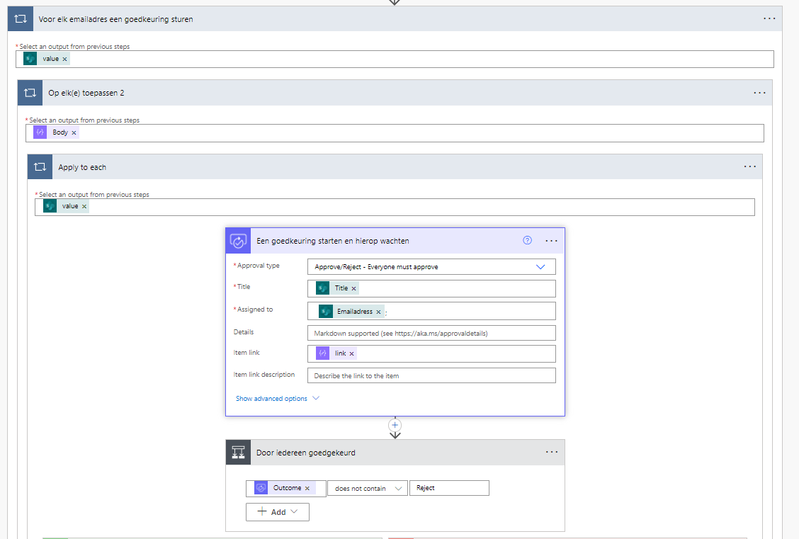  If all all the employees approve the projects then the answere is yes and nothing changes. If one or more employees rejects this then the flow goes to no
10.5A | 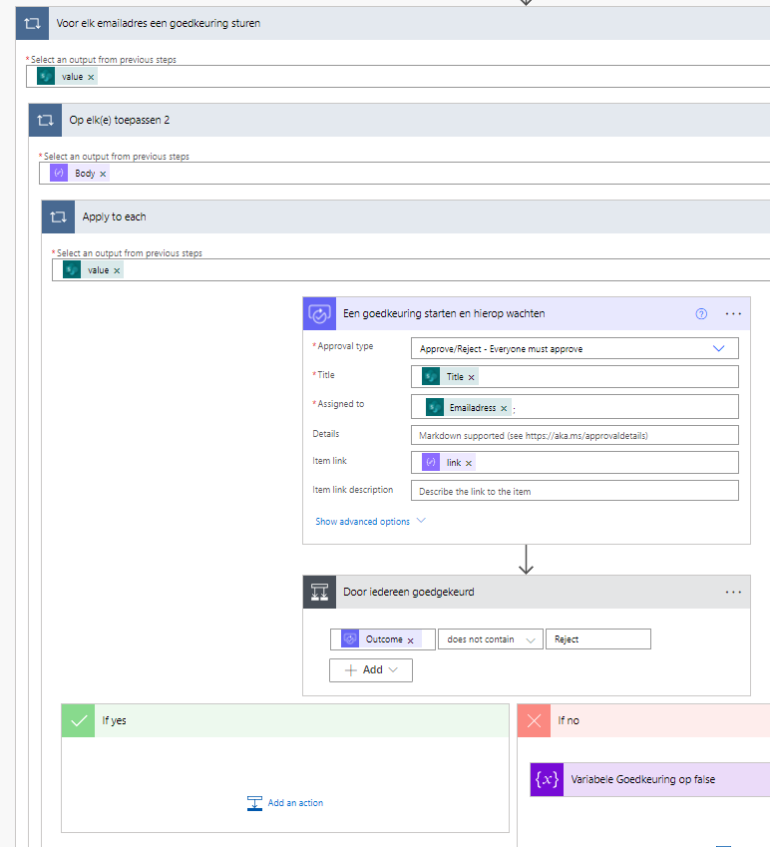  If everyone has approved the project, then the flow goes to ‘yes’ and continues forwards
10.5B | 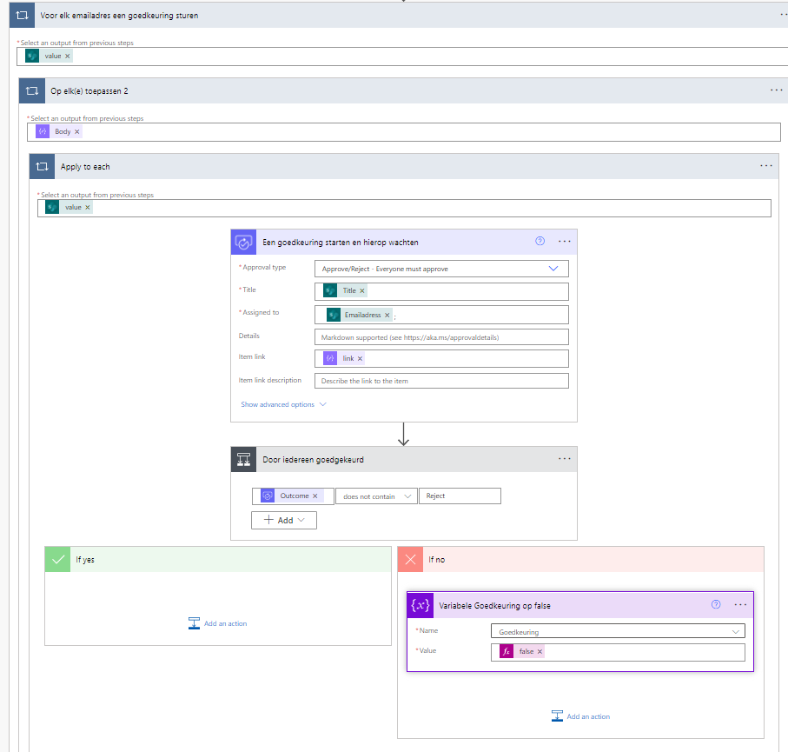  If one of the employees rejects the proposal, then the variable in 9 gets changed from ‘true’ to ‘false’ | {  "inputs": {  "name": "Goedkeuring",  "value": "@false"  },  "metadata": {  "operationMetadataId": "33d36ac9-6852-46f5-b485-223682582f20"  }  }
11 | 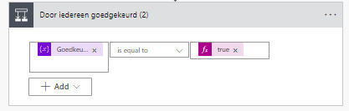  This step looks if the variable is still true or false. If true it goes to yes if false then it goes to no.
11.1A | 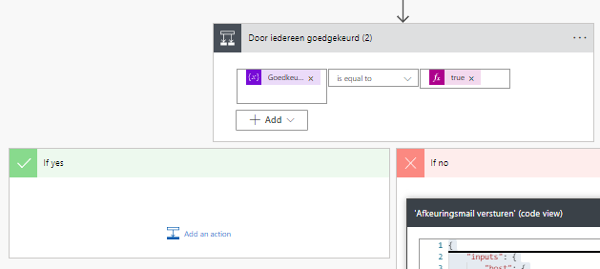  If the answer is true the flow will continue
11.1B | 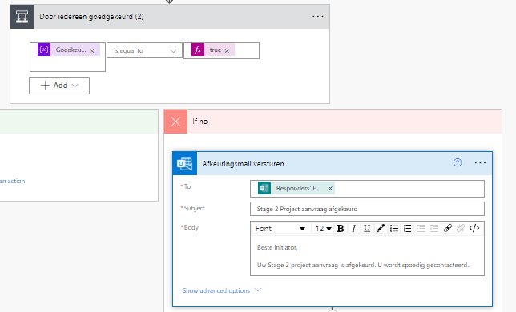  In this step An email will be send to the responder informing them that the project has been rejected. | {  "inputs": {  "host": {  "connectionName": "shared_office365",  "operationId": "SendEmailV2",  "apiId": "/providers/Microsoft.PowerApps/apis/shared_office365"  },  "parameters": {  "emailMessage/To": "@outputs('Reactiedetails_ophalen_(Stage_2)')?['body/responder']",  "emailMessage/Subject": "Stage 2 Project aanvraag afgekeurd",  "emailMessage/Body": "<p>Beste initiator,<br>\n<br>\nUw Stage 2 project aanvraag is afgekeurd. U wordt spoedig gecontacteerd.</p>"  },  "authentication": "@parameters('$authentication')"  },  "metadata": {  "operationMetadataId": "33e8a170-d60d-4ea1-b8b2-002d324b6193"  }  }
11.2B | 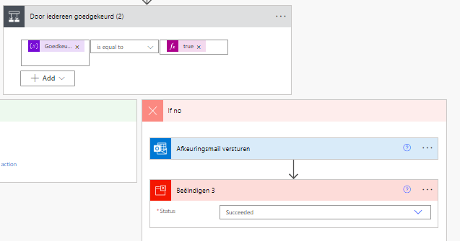  This step ends the flow | {  "metadata": {  "operationMetadataId": "2af3d994-c127-4a24-9aa5-99953d0ffc15"  },  "inputs": {  "runStatus": "Succeeded"  }  }
12.1 | 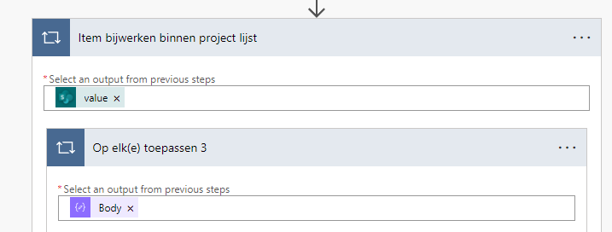  This step takes the Json variables from step 4, and enables the usage of all variables in step 8.2
12.2 | 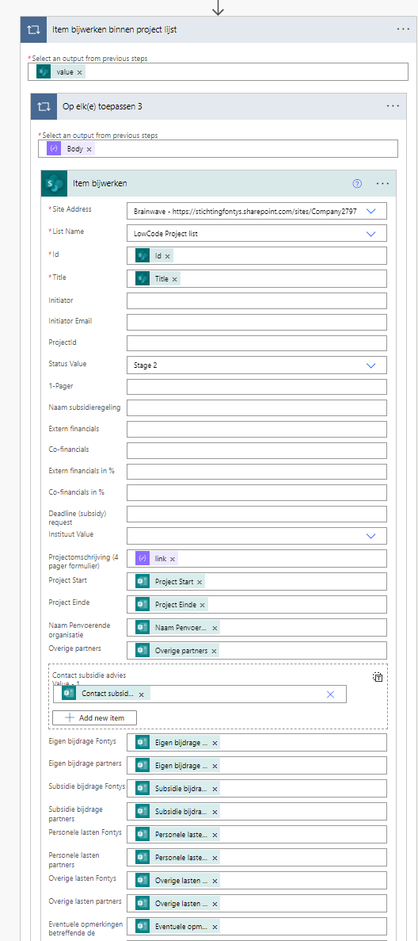  This step takes all the answeres from the from “Projectaanvraag (Stage 2)” and adds this data to the “LowCode Project List” database. The project status is changed to “Stage 2 and this data is added to the correct row by varifying the ProjectId, making the information within SharePoint List cumulative.  The following values are added to the database :  -Project start date  -Project end date  -Name coordinating organization  -Other partners  -HTTML link to the “project omschrijving (4 pager formulier) document”  -Own contribution Fontys  -Own contribution partners  -Subsidie contribution Fontys  -Subsidie contribution Partners  -Personnel costs Fontys  -Personel costs partners  -Other costs Fontys  -Other costs Partners  -Additional comment on the budget. | {  "inputs": {  "host": {  "connectionName": "shared_sharepointonline",  "operationId": "PatchItem",  "apiId": "/providers/Microsoft.PowerApps/apis/shared_sharepointonline"  },  "parameters": {  "dataset": "https://stichtingfontys.sharepoint.com/sites/Company2797",  "table": "7fc526fe-a48a-4dd2-a2fa-283b564af813",  "id": "@items('Item_bijwerken_binnen_project_lijst')?['ID']",  "item/Title": "@items('Item_bijwerken_binnen_project_lijst')?['Title']",  "item/Status/Value": "Stage 2",  "item/Projectomschrijving_x0028_4pager": "@items('Op_elk(e)_toepassen_3')['link']",  "item/Projectstart": "@outputs('Reactiedetails_ophalen_(Stage_2)')?['body/r841e2c8a69dd4782ad2c8316789365ee']",  "item/ProjectEinde": "@outputs('Reactiedetails_ophalen_(Stage_2)')?['body/r9d88d43556404ba5b89a0535859bb9b9']",  "item/NaamPenvoerendeorganisatie": "@outputs('Reactiedetails_ophalen_(Stage_2)')?['body/r41f9fa60cd144512beaff625feacbb01']",  "item/Overigepartners": "@outputs('Reactiedetails_ophalen_(Stage_2)')?['body/r34a74bea2dfd4398a2d60ac5259b2ca5']",  "item/Contactsubsidieadvies": [  {  "Value": "@outputs('Reactiedetails_ophalen_(Stage_2)')?['body/ree9a36268b374cac8c5613b2088437bb']"  }  ],  "item/EigenbijdrageFontys": "@outputs('Reactiedetails_ophalen_(Stage_2)')?['body/r9f36c79fafd24c10958c0221c92a614e']",  "item/Eigenbijdragepartners": "@outputs('Reactiedetails_ophalen_(Stage_2)')?['body/rb95c01ca67f042c19d8890fb1c572b5a']",  "item/SubsidiebijdrageFontys": "@outputs('Reactiedetails_ophalen_(Stage_2)')?['body/rfc333cf785d44299aa31c29da0dedcca']",  "item/Subsidiebijdragepartners": "@outputs('Reactiedetails_ophalen_(Stage_2)')?['body/r264ee73f7b9a4b15949adc5537273b95']",  "item/PersonelelastenFontys": "@outputs('Reactiedetails_ophalen_(Stage_2)')?['body/r76742b04e30f43649908703022f16df2']",  "item/Personelelastenpartners": "@outputs('Reactiedetails_ophalen_(Stage_2)')?['body/re9c20962416448068db685b500636b51']",  "item/OverigelastenFontys": "@outputs('Reactiedetails_ophalen_(Stage_2)')?['body/r56afbb5a2f1445f9a76fd37f62407e5a']",  "item/Overigelastenpartners": "@outputs('Reactiedetails_ophalen_(Stage_2)')?['body/rf351fefd966241d8aa4e218a3187233e']",  "item/Eventueleopmerkingenbetreffended": "@outputs('Reactiedetails_ophalen_(Stage_2)')?['body/r86b56aa12a9b48e4ab9eef0611c9a317']"  },  "authentication": "@parameters('$authentication')"  },  "metadata": {  "operationMetadataId": "8aed0fbc-58f5-43dc-96f2-fc98b49982e1"  }  }
13 | 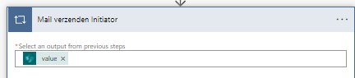
13.1 | 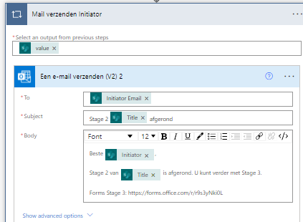  This step sends an email to the initiator. Confirming that the project has been approved an succesfully finished stage 2. The initiator is provided with a link to the form for stage 3 | {  "inputs": {  "host": {  "connectionName": "shared_office365",  "operationId": "SendEmailV2",  "apiId": "/providers/Microsoft.PowerApps/apis/shared_office365"  },  "parameters": {  "emailMessage/To": "@items('Mail_verzenden_Initiator_')?['InitiatorEmail']",  "emailMessage/Subject": "Stage 2 @{items('Mail_verzenden_Initiator_')?['Title']} afgerond",  "emailMessage/Body": "<p>Beste @{items('Mail_verzenden_Initiator_')?['Initiator']},<br>\n<br>\nStage 2 van @{items('Mail_verzenden_Initiator_')?['Title']} is afgerond. U kunt verder met Stage 3.<br>\n<br>\nForms Stage 3: https://forms.office.com/r/r9s3yNki0L&nbsp;</p>"  },  "authentication": "@parameters('$authentication')"  },  "metadata": {  "operationMetadataId": "83aed467-6391-4847-be12-f2c57ba6edbc"  }  }
14 | 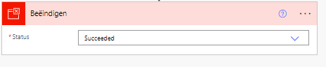  This step ends the flow so that it cannot be stuk in an infinate loop. | {  "metadata": {  "operationMetadataId": "2d451d43-8b76-4353-9e53-13dea8194be1"  },  "inputs": {  "runStatus": "Succeeded"  }  }

8. Flow & Code Stage 3
This chapter will visualize and explain the flow created for stage 3 out of 3 by Brainwave within Microsoft Power Automate. This flow contains 13 steps, all steps and code are displayed in table 17

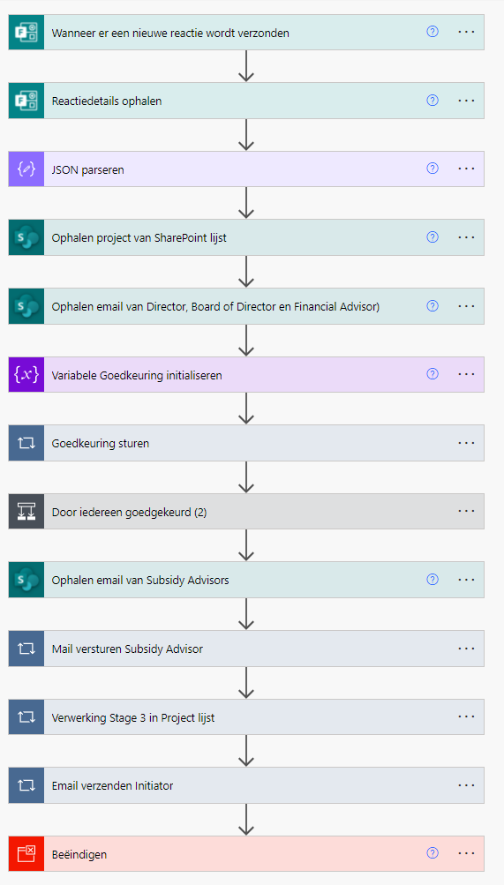
Figure 19 Microsoft Power Automate Flow Stage 3

Step | Explanation | Code
1 | 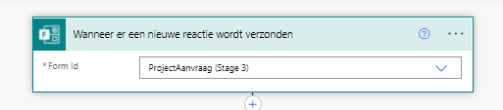  This first step is the trigger for the flow. It starts when “Project Aanvraag Stage 3” in forms is filled in. | {  "inputs": {  "host": {  "connectionName": "shared_microsoftforms",  "operationId": "CreateFormWebhook",  "apiId": "/providers/Microsoft.PowerApps/apis/shared_microsoftforms"  },  "parameters": {  "form_id": "ZWdrxpS3K0qE7YRbNBwIarALHKSIwAJGkfucnkYjEYhUQUhYTVZQN1oxS0xXTUZCRldPVDBSSVdWUy4u"  },  "authentication": "@parameters('$authentication')"  },  "metadata": {  "operationMetadataId": "7bd1f6bd-3872-408f-82c3-d0eeca9b7735"  },  "splitOn": "@triggerOutputs()?['body/value']"  }
2 | 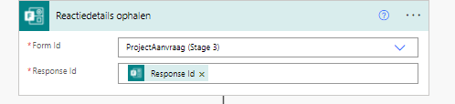  This step will the extract the data from the “Aanvraag Fomrulier Stage 2” form. | {  "inputs": {  "host": {  "connectionName": "shared_microsoftforms",  "operationId": "GetFormResponseById",  "apiId": "/providers/Microsoft.PowerApps/apis/shared_microsoftforms"  },  "parameters": {  "form_id": "ZWdrxpS3K0qE7YRbNBwIarALHKSIwAJGkfucnkYjEYhUQUhYTVZQN1oxS0xXTUZCRldPVDBSSVdWUy4u",  "response_id": "@triggerOutputs()?['body/resourceData/responseId']"  },  "authentication": "@parameters('$authentication')"  },  "metadata": {  "operationMetadataId": "1a9f6328-2f52-434c-8cdd-acb666d6383d"  }  }
3 | 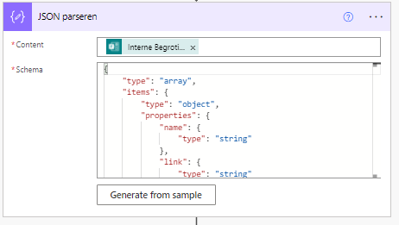  In this step JSON separate all the variables of the “Project Omschrijving (4 pager formulier) which come from the document. These are the following:  -Name  -Link  -ID  -ReferenceId  -Driveld  -Size  -Status  Instead of a whole string containing all these variables breaking the hyperlink when used in other stages. | {  "inputs": {  "content": "@outputs('Reactiedetails_ophalen')?['body/r7286cdf756444e319a79d5ca463cf929']",  "schema": {  "type": "array",  "items": {  "type": "object",  "properties": {  "name": {  "type": "string"  },  "link": {  "type": "string"  },  "id": {  "type": "string"  },  "type": {},  "size": {  "type": "integer"  },  "referenceId": {  "type": "string"  },  "driveId": {  "type": "string"  },  "status": {  "type": "integer"  },  "uploadSessionUrl": {}  },  "required": [  "name",  "link",  "id",  "type",  "size",  "referenceId",  "driveId",  "status",  "uploadSessionUrl"  ]  }  }  },  "metadata": {  "operationMetadataId": "ed4c2779-10ef-41e8-8bfc-e91d7f56fe38"  }  }
4 | 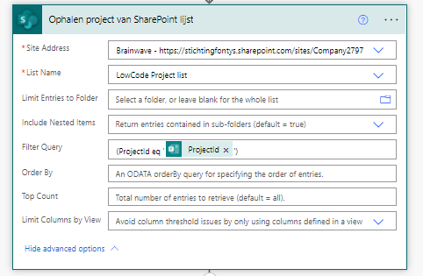  This step gathers the row created by the first stage of forms and Microsoft Power automate from the SharePoint list “LowCode Project List”. This is done by using the ProjectId gather by forms and using this as a filter in the SharePoint List. | {  "inputs": {  "host": {  "connectionName": "shared_sharepointonline",  "operationId": "GetItems",  "apiId": "/providers/Microsoft.PowerApps/apis/shared_sharepointonline"  },  "parameters": {  "dataset": "https://stichtingfontys.sharepoint.com/sites/Company2797",  "table": "7fc526fe-a48a-4dd2-a2fa-283b564af813",  "$filter": "(ProjectId eq '@{outputs('Reactiedetails_ophalen')?['body/r23b26e375c204c64816b48686a102807']}')"  },  "authentication": "@parameters('$authentication')"  },  "metadata": {  "operationMetadataId": "e869f14f-d30a-45b5-83f8-a4f745d13046"  }  }
5 | 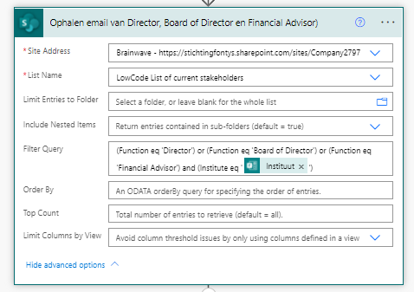  This step gathers emailadresses of the functions: Director, Financial Advisor. These emailadresses are gathered from the “LowCode List Of Current Stakeholders”. These emailadresses are filted on function and institute which the lecturer has answered in the form “Aanvraag Fomrulier Stage 3”. | {  "inputs": {  "host": {  "connectionName": "shared_sharepointonline",  "operationId": "GetItems",  "apiId": "/providers/Microsoft.PowerApps/apis/shared_sharepointonline"  },  "parameters": {  "dataset": "https://stichtingfontys.sharepoint.com/sites/Company2797",  "table": "71bde792-7934-4bd6-92cd-2321c90cf55b",  "$filter": "(Function eq 'Director') or (Function eq 'Board of Director') or (Function eq 'Financial Advisor') and (Institute eq '@{outputs('Reactiedetails_ophalen')?['body/r24f2ff3215fb480a870dcb147584d661']}')"  },  "authentication": "@parameters('$authentication')"  },  "metadata": {  "operationMetadataId": "2596d7de-2f3c-48b0-94e7-78371b8e5ad0"  }  }
7 | This step sets a variable to true. This is due to step 8 not having the option for a condition action | {  "inputs": {  "variables": [  {  "name": "Goedkeuring",  "type": "boolean",  "value": "@true"  }  ]  },  "metadata": {  "operationMetadataId": "7c009df0-d1b2-451c-9917-bce8d6f4494e"  }
6 | 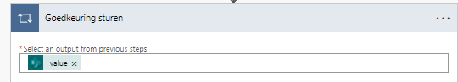  This step takes the emailadresses from step 5, by selecting the output. These emailadresses are used in step 7.3
7.1 | 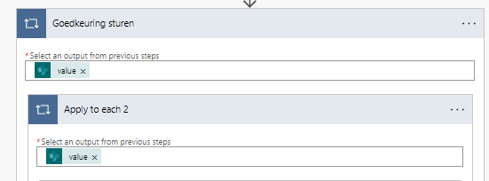  This step takes all the previous acquired project information, which is received from step 4. This enables 7.3 to use all the information from the database.
7.2 | 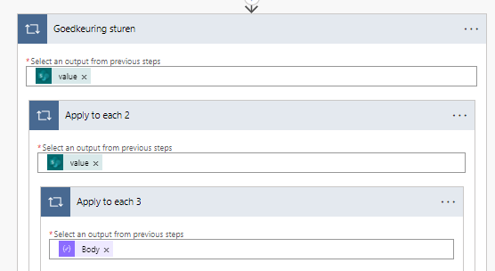  This step takes the Json variables from step 3, and enables the usage of all variables in step 6.3
7.3 | 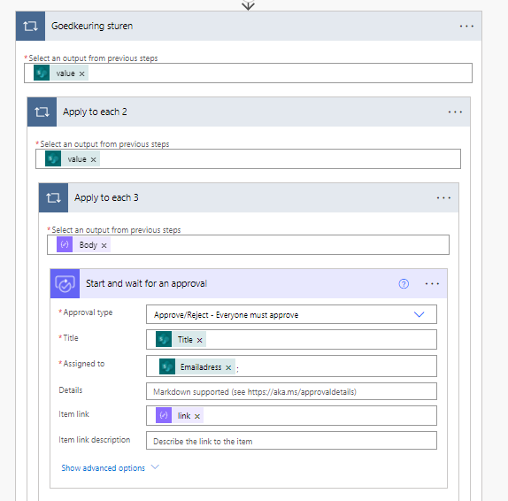  This step starts the approvals for the Director and Financial Advisor. It send an email to these functions which are gathered from step 7. This email contains an approval or deniel option, the title of the project and the new attachment from the new form “Internal Budget”.Must all approve the project in order for it to continue. If any of them denies this proposal then the initiator will receive the feedback given by set employee and the flow ends. | {  "inputs": {  "host": {  "connectionName": "shared_approvals",  "operationId": "StartAndWaitForAnApproval",  "apiId": "/providers/Microsoft.PowerApps/apis/shared_approvals"  },  "parameters": {  "approvalType": "BasicAwaitAll",  "WebhookApprovalCreationInput/title": "@items('Goedkeuring_sturen')?['Title']",  "WebhookApprovalCreationInput/assignedTo": "@{items('Apply_to_each_2')?['Emailadress']};",  "WebhookApprovalCreationInput/itemLink": "@items('Apply_to_each_3')['link']",  "WebhookApprovalCreationInput/enableNotifications": true,  "WebhookApprovalCreationInput/enableReassignment": true  },  "authentication": "@parameters('$authentication')"  },  "metadata": {  "operationMetadataId": "0157ef5c-0e2a-44e9-864f-40fcd9b25218"  }  }
7.4 | 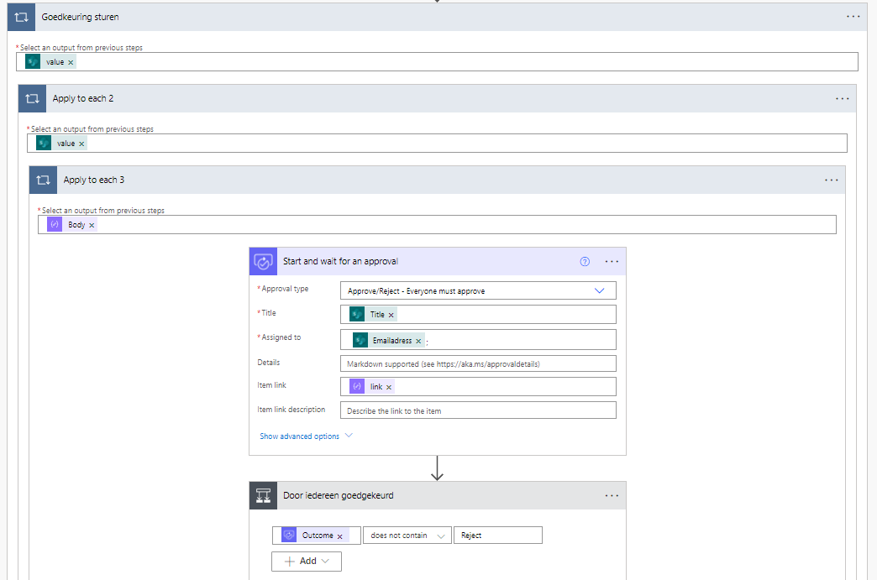  This step looks if one the employees has rejected the proposal. If all has been approved then it continiues to yes, if not then it continious to no.
7.5A | 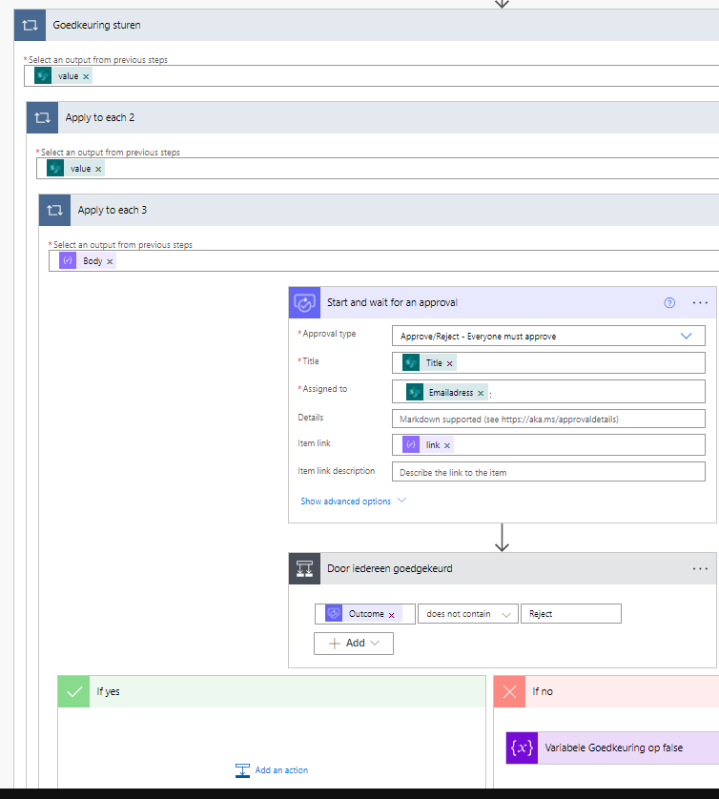  If everyone has approved the project, then the flow goes to ‘yes’ and continues forwards
 | 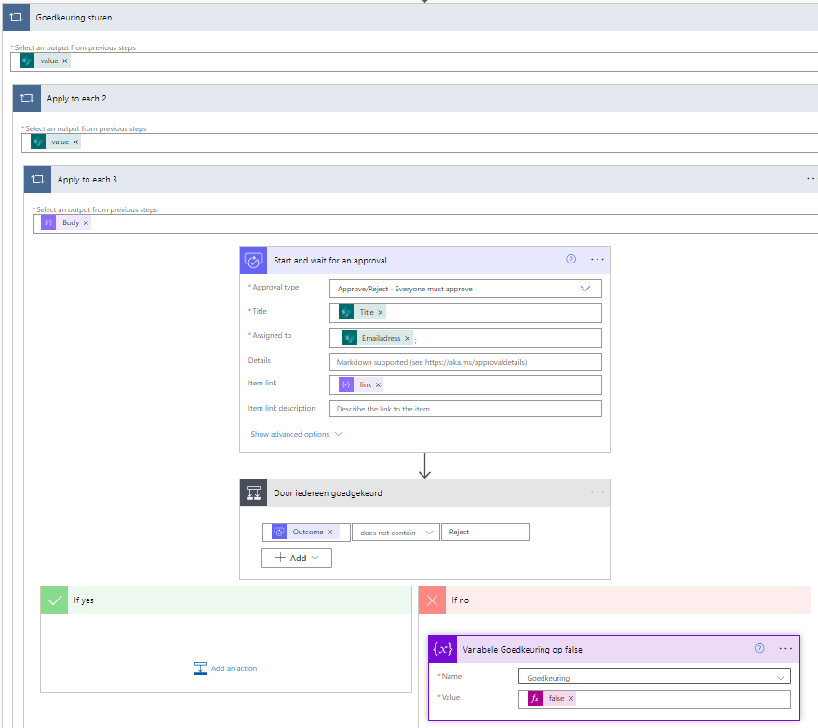  This step looks if one or more employees have rejects the proposal, then the variable in 7 gets changed from ‘true’ to ‘false’ | {  "inputs": {  "name": "Goedkeuring",  "value": "@false"  },  "metadata": {  "operationMetadataId": "06bbc7dc-9893-4296-9825-410e49e9898e"  }  }
8 | 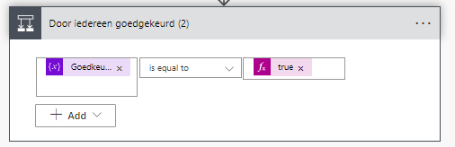  This step looks if the variable is still true or false. If true it goes to yes if false then it goes to no.
8.1A | 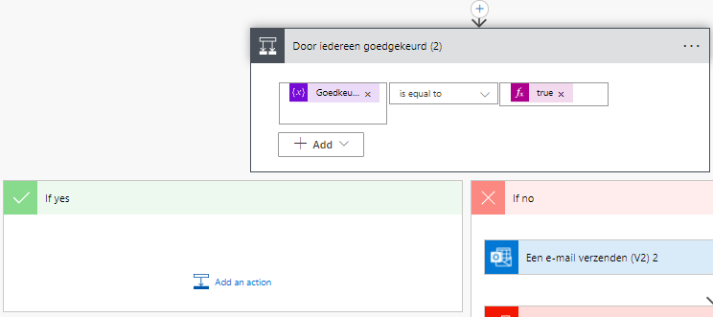  If the answer is true the flow will continue
8.2B | 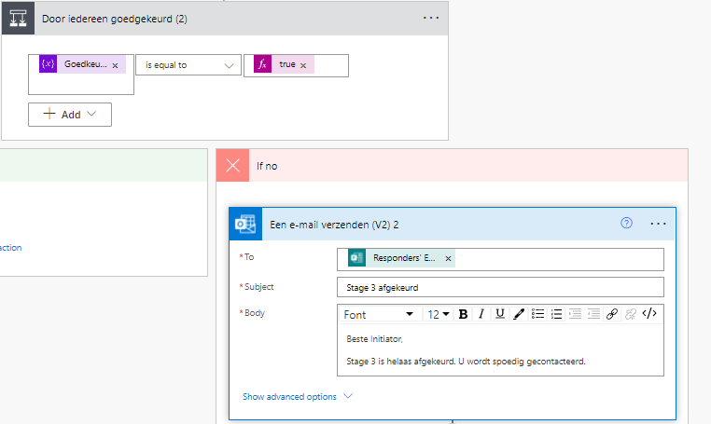  This step sends An email to the responder informing them that the project has been rejected. | {  "inputs": {  "host": {  "connectionName": "shared_office365_1",  "operationId": "SendEmailV2",  "apiId": "/providers/Microsoft.PowerApps/apis/shared_office365"  },  "parameters": {  "emailMessage/To": "@outputs('Reactiedetails_ophalen')?['body/responder']",  "emailMessage/Subject": "Stage 3 afgekeurd",  "emailMessage/Body": "<p>Beste Initiator,<br>\n<br>\nStage 3 is helaas afgekeurd. U wordt spoedig gecontacteerd.</p>"  },  "authentication": "@parameters('$authentication')"  },  "metadata": {  "operationMetadataId": "e60643bc-e724-49bc-8540-43cca78ed285"  }  }
8.3B | 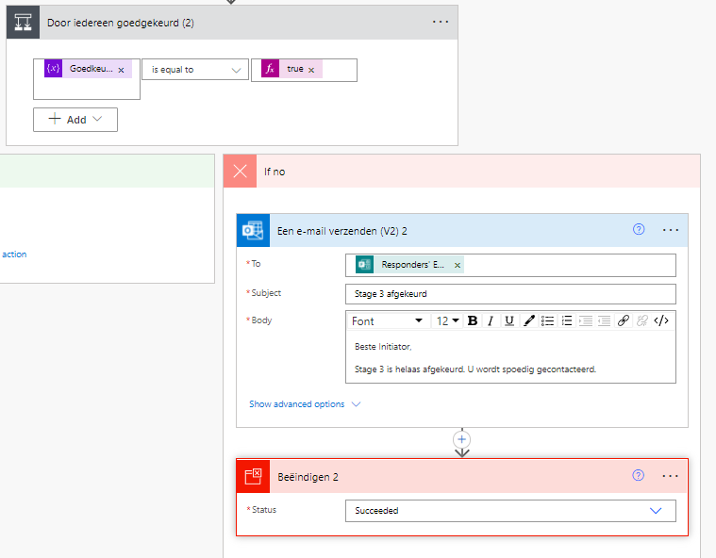  This step ends the flow | {  "metadata": {  "operationMetadataId": "39914a40-880e-47a8-872f-53e22a26b21a"  },  "inputs": {  "runStatus": "Succeeded"  }  }
9 | 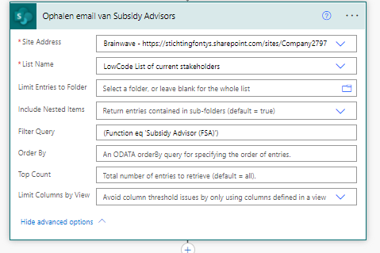  This step gathers emailadresses of the function: Subsidy Advisor (FSA). These emailadresses are gathered from the “LowCode List Of Current Stakeholders”. These emailadresses are filted on function. | {  "inputs": {  "host": {  "connectionName": "shared_sharepointonline",  "operationId": "GetItems",  "apiId": "/providers/Microsoft.PowerApps/apis/shared_sharepointonline"  },  "parameters": {  "dataset": "https://stichtingfontys.sharepoint.com/sites/Company2797",  "table": "71bde792-7934-4bd6-92cd-2321c90cf55b",  "$filter": "(Function eq 'Subsidy Advisor (FSA)') "  },  "authentication": "@parameters('$authentication')"  },  "metadata": {  "operationMetadataId": "da0dd3c7-68ed-45b5-9bd5-88e72c371e85"  }  }
10 | 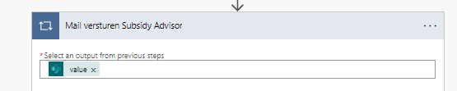  This step takes the emailadresses from step 7, by selecting the output. These emailadresses are used in step 8.2
10.1 | 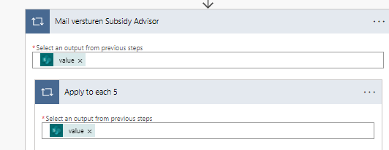  This step takes all the previous acquired project information, which is received from step 4. This enables 7.3 to use all the information from the database.
10.2 | 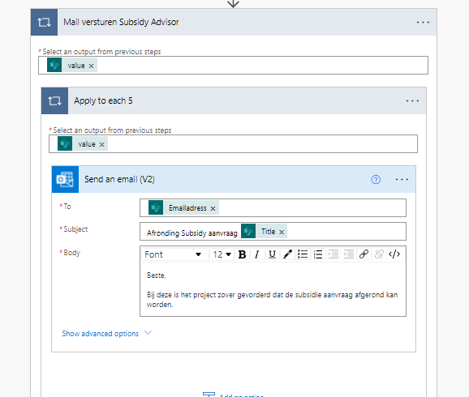  This step sends an email to the subsidy advisors, confirming that the project has been past all approvals and that stage 3 has been finished. | {  "inputs": {  "host": {  "connectionName": "shared_office365",  "operationId": "SendEmailV2",  "apiId": "/providers/Microsoft.PowerApps/apis/shared_office365"  },  "parameters": {  "emailMessage/To": "@items('Mail_versturen_Subsidy_Advisor')?['Emailadress']",  "emailMessage/Subject": "Afronding Subsidy aanvraag @{items('Apply_to_each_5')?['Title']}",  "emailMessage/Body": "<p>Beste,<br>\n<br>\nBij deze is het project zover gevorderd dat de subsidie aanvraag afgerond kan worden.</p>"  },  "authentication": "@parameters('$authentication')"  },  "metadata": {  "operationMetadataId": "d98ed078-246c-42f6-81ee-26f8f2f52e1f"  }  }
11 | 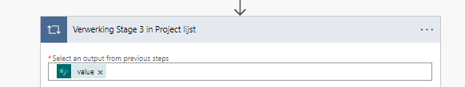  This step takes all the previous acquired project information, which is received from step 4. This enables 8.2 to use all the information from the database.
11.1 | 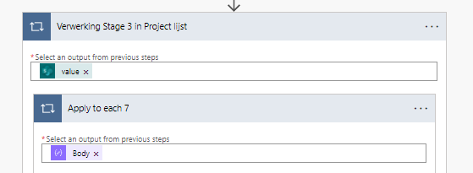  This step takes the Json variables from step 3, and enables the usage of all variables in step 9.2
11.2 | 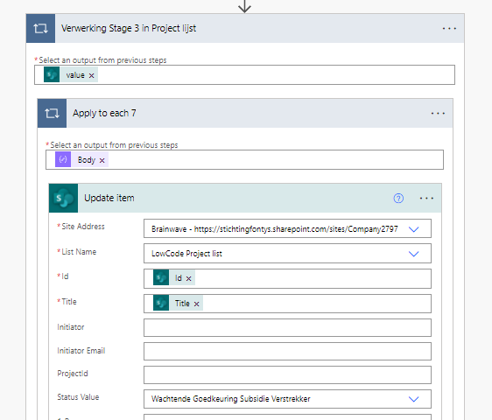  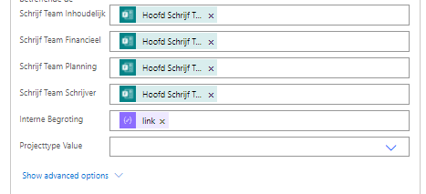  This step takes all the answeres from the from “Projectaanvraag (Stage 3)” and adds this data to the “LowCode Project List” database. The project status is changed to “Wachtende Goedkeuring Subsidie Verstrekker” and this data is added to the correct row by verifying the ProjectId.  The following values are added to the database :  -Writing team content  -Writing team Financial  -Writing team Planning  -Writing team writer  -HTTML link to the “Internal Budget” | {  "inputs": {  "host": {  "connectionName": "shared_sharepointonline",  "operationId": "PatchItem",  "apiId": "/providers/Microsoft.PowerApps/apis/shared_sharepointonline"  },  "parameters": {  "dataset": "https://stichtingfontys.sharepoint.com/sites/Company2797",  "table": "7fc526fe-a48a-4dd2-a2fa-283b564af813",  "id": "@items('Verwerking_Stage_3_in_Project_lijst')?['ID']",  "item/Title": "@items('Verwerking_Stage_3_in_Project_lijst')?['Title']",  "item/Status/Value": "Wachtende Goedkeuring Subsidie Verstrekker",  "item/SchrijfTeamInhoudelijk": "@outputs('Reactiedetails_ophalen')?['body/rd2bb00d904a544deacf529de1c23e1c1']",  "item/SchrijfTeamFinancieel": "@outputs('Reactiedetails_ophalen')?['body/r2035503bbd634ed5afc5bd40368a666f']",  "item/SchrijfTeamPlanning": "@outputs('Reactiedetails_ophalen')?['body/rd52e8f88c6dc4fa186a291a7756889a7']",  "item/SchrijfteamSchrijver": "@outputs('Reactiedetails_ophalen')?['body/r60acde5c69cd46fcb418047f96afa012']",  "item/Internebegroting": "@items('Apply_to_each_7')['link']"  },  "authentication": "@parameters('$authentication')"  },  "metadata": {  "operationMetadataId": "f23e8088-e5f2-42ba-a8fc-2a6790a0c084"  }  }
12 | 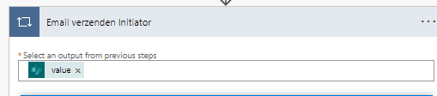  This step takes the information from the sharepoint list and allows it to be used in step 12.1
12.1 | 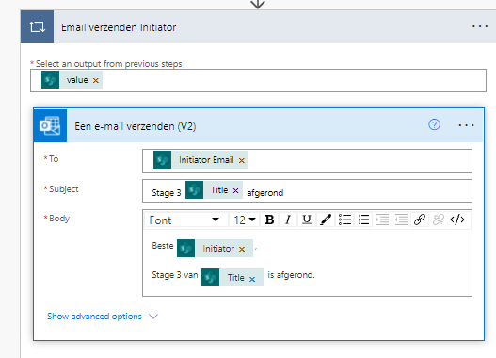  This step sends an email to the initiator stating that stage 3 is completed. | {  "inputs": {  "host": {  "connectionName": "shared_office365_1",  "operationId": "SendEmailV2",  "apiId": "/providers/Microsoft.PowerApps/apis/shared_office365"  },  "parameters": {  "emailMessage/To": "@items('Email_verzenden_Initiator')?['InitiatorEmail']",  "emailMessage/Subject": "Stage 3 @{items('Email_verzenden_Initiator')?['Title']} afgerond",  "emailMessage/Body": "<p>Beste @{items('Email_verzenden_Initiator')?['Initiator']},<br>\n<br>\nStage 3 van @{items('Email_verzenden_Initiator')?['Title']} is afgerond.</p>"  },  "authentication": "@parameters('$authentication')"  },  "metadata": {  "operationMetadataId": "8a1cfe6d-9ebb-4847-b7d6-89ab88f3f8bb"  }  }
13 | 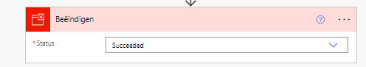  This step ends the flow so that it cannot be stuk in an infinate loop. | {  "metadata": {  "operationMetadataId": "17d1374e-0803-4903-8d77-d2b9953188d5"  },  "inputs": {  "runStatus": "Succeeded"  }  }

8. Flow & Code Power Power BI “Initiator overzicht”

This chapter will visualize and explain the “initiator overzicht” dashboard in Power BI.

This translates into initiator overview. This dashboard gives the initiator additional information on their current projects. This Overview consist of 4 different visualizations, slicer and a navigation menu shown in figure 18. The navigation menu is the same for each dashboard but will only be explain within this chapter.

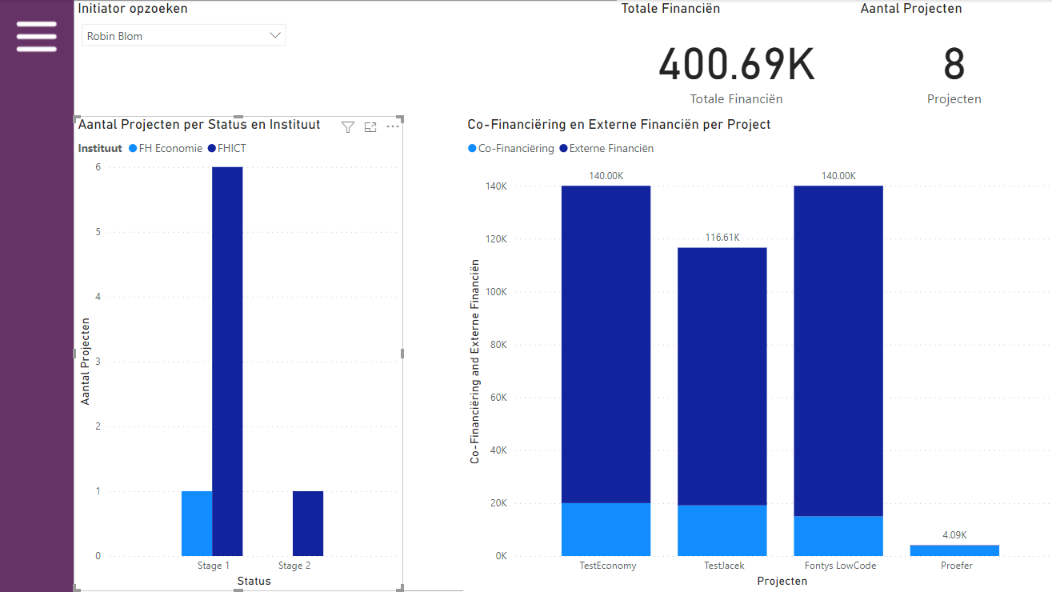
Figure 20 Initiator Overzicht Dashboard

Dashboard number |  | Explanation | Code
1 |   This is the symbol used for the menu navigation. This symbol is the same for each dashboard page. Pressing the button will open a window with all dashboard pages, allowing the user to navigate to a dashboard page |  | This is done by creating bookmarks for the page with the menu opened and closed. It has do be done manually for each dashboard page.
1.1 | 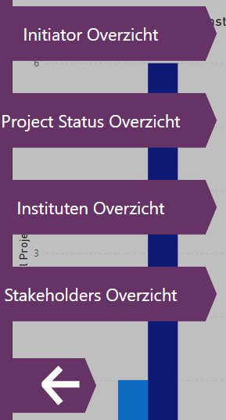  This is the navigation menu. A user can navigate to a page by pressing on the name of those projects. The menu is closed by pressing the left pointing arrow. |  | -
2 | 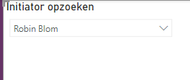  This slicer filters on initiator. It allows the user to investigate the specific data from the chosen imitator. This filter will then be applied to all visualizations on this page. |  | Source: LowCodeProjectList (SharePoint list)  field: Initiator
3 | 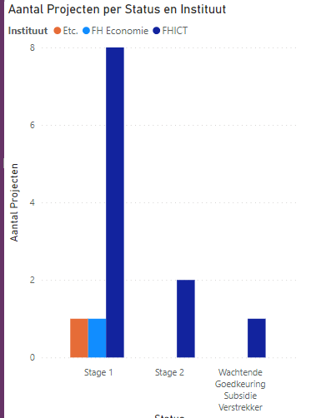  This clustered column chart displays the amount of projects there are, at what stage they currently are and what institute is responsible for the projects. |  | Source: LowCodeProjectList (SharePoint list)  Axis: status  Legend: Instituut  Values: Aantal Projecten
4 | 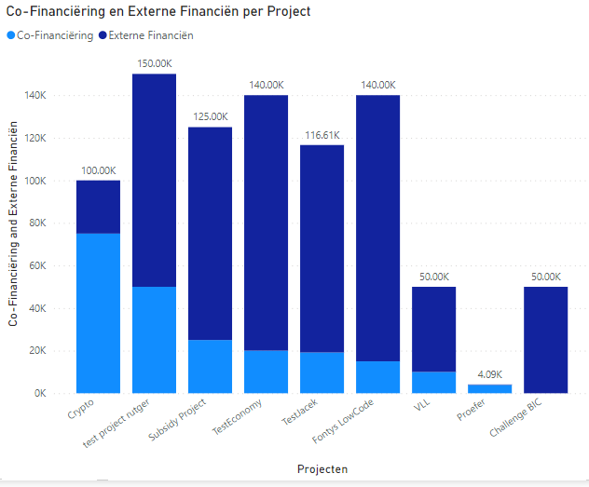  This stacked column chart displays the amount of co-financing and external financing per project. With the light blue displaying the co-financing from Fontys and the dark blue displaying the external financing. |  | Source: LowCodeProjectList (SharePoint list)  Axis: Projecten  Values: Co-Financiëring & Externe Financiën
5 | 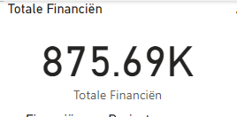  This card displays the total amount of financing Fontys would need to provide for the projects at the approval stage. |  | Fields: Totale Financials  Measure: TotaleFinancials = SUMX(LowCodeProjectList, LowCodeProjectList[CoFinancials] + LowCodeProjectList[ExternFinancials])
6 | 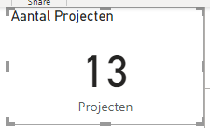  This card displays the total amount or project at one of the 3 stages. |  | Source: LowCodeProjectList (SharePoint list)  Fields: Projecten

9. Flow & Code Power Power BI “Projecten Financieel Overzicht”

This chapter will visualize and explain the “Projecten Financieel Overzicht” dashboard in Power BI.

This translates into project financial overview. This Overview displays the financial information of each individual project, this is done by 7 different visualizations displayed in figure 19.

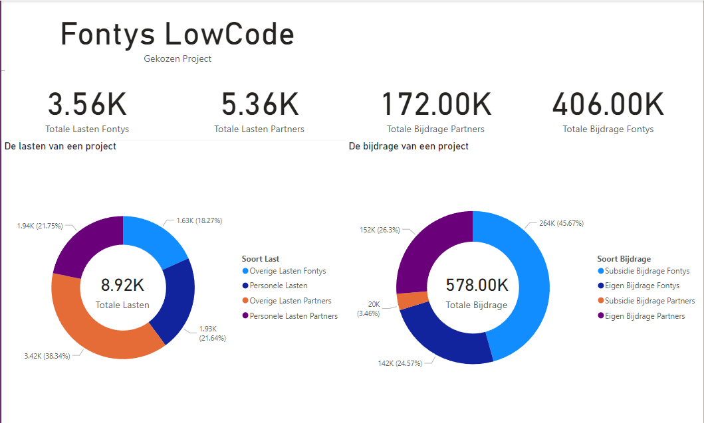
Figure 21 Projecten Financieel Overzicht dashboard

Dashboard number |  | Explanation | Code
1 | 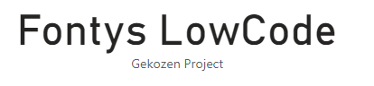  This card displays the currently chosen project for the other visualizations |  | Source: LowCodeProjectList (SharePoint list)  Field: Title
2 | 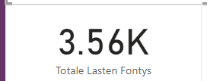  This card displays the current costs this project would ensue for this project by the Fontys. |  | Fields: totale Lasten Fontys  Measure: TotaleLastenFontys = SUMX(LowCodeProjectList, LowCodeProjectList[PersoneleLastenFontys] + LowCodeProjectList[OverigeLastenFontys])
3 | 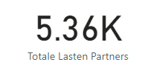  This card displays the current costs this project would ensue for this project by the partners |  | Fields: Totale Lasten Partners  Measure: TotaleLastenPartners = SUMX(LowCodeProjectList, LowCodeProjectList[PersoneleLastenPartners] + LowCodeProjectList[OverigeLastenPartners])
4 | 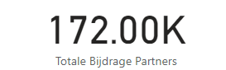  This card displays the total amount of funding Fontys would need to put into the Fontys. |  | Fields: Totale Bijdrage Partners  Measure: TotaleBijdragePartners = SUMX(LowCodeProjectList, LowCodeProjectList[EigenBijdragePartners] + LowCodeProjectList[SubsidieBijdragePartners])
5 | 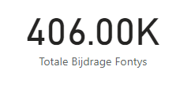  This card displays the total amount of funding Fontys would need to put into the project. |  | Fields: Totale Bijdrage Fontys  Measure: TotaleBijdrageFontys = SUMX(LowCodeProjectList, LowCodeProjectList[EigenBijdrageFontys] + LowCodeProjectList[SubsidieBijdrageFontys])
6 | 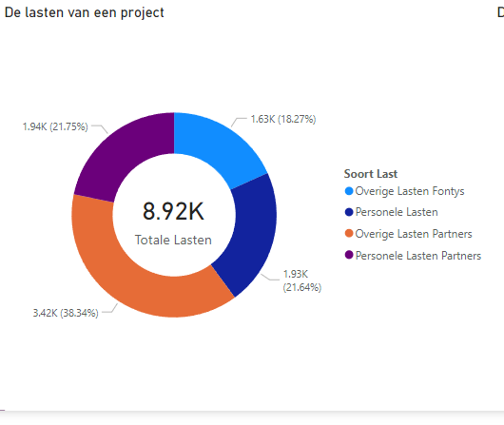  This donut chart breaks down all the costs Fontys and the Partners would ensue. |  | Source: LowCodeProjectList  Values: Overige Lasten Fontys, Personele Lasten, Overige Lasten Partners, Personele Lasten Partners
7 | 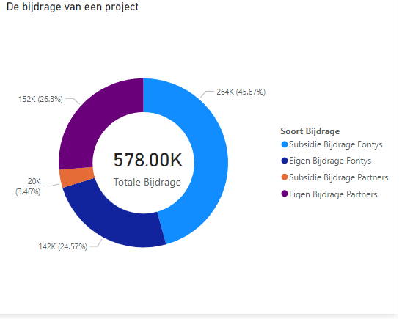  This Donut chart displays the amount of Funding Fontys and the partners would need to put into the project. |  | Source: LowCodeProjectList  Values: Subsidie Bijdrage Fontys, Eigen Bijdrage Fontys, Subsidie Bijdrage Partners, Eigen Bijdrage Partners

10. Flow & Code Power Power BI “Project Status Overzicht”

This chapter will visualize and explain the “Project Status Overzicht” dashboard in Power BI.

This translates into Project status overview. This dashboard provides an overview on how many projects are currently present in each stage. This dashboard uses that information and uses this to calculate how many projects are currently longer then 5 days in each status. The overview consist of 2 slicers and 4 graphs displayed in figure 20.
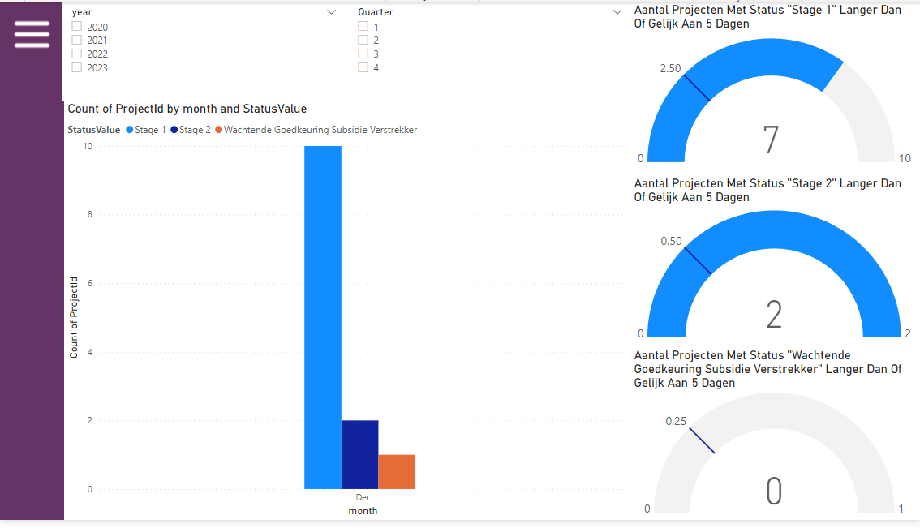
Figure 22 Project Status Overzicht Dashboard

Dashboard number |  | Explanation | Code
1 | 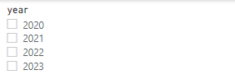  This slicer filters on in what year(s) projects started and filter the rest of the visualization on this page. |  | Source: DIM_Date  Field: Year  DIM_Date = ADDCOLUMNS(  CALENDARAUTO(),  "year", FORMAT([Date], "yyyy"),  "quarter", QUARTER([Date]),  "monthnr", MONTH([Date]),  "month", FORMAT([Date], "mmm"),  "week", WEEKNUM([Date], 2),  "wdnr", WEEKDAY([Date]-1),  "weekday", FORMAT([Date], "ddd"),  "weekend", IF(OR(WEEKDAY([Date]-1) = 6, WEEKDAY([Date]-1) = 7), TRUE(), FALSE())  )
2 | 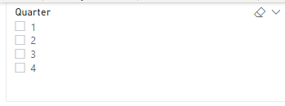  This slicer filters on in what quarter(s) projects started and filter the rest of the visualization on this page. |  | Source: DIM_Date  Field: Quarter  DIM_Date = ADDCOLUMNS(  CALENDARAUTO(),  "year", FORMAT([Date], "yyyy"),  "quarter", QUARTER([Date]),  "monthnr", MONTH([Date]),  "month", FORMAT([Date], "mmm"),  "week", WEEKNUM([Date], 2),  "wdnr", WEEKDAY([Date]-1),  "weekday", FORMAT([Date], "ddd"),  "weekend", IF(OR(WEEKDAY([Date]-1) = 6, WEEKDAY([Date]-1) = 7), TRUE(), FALSE())  )
3 | 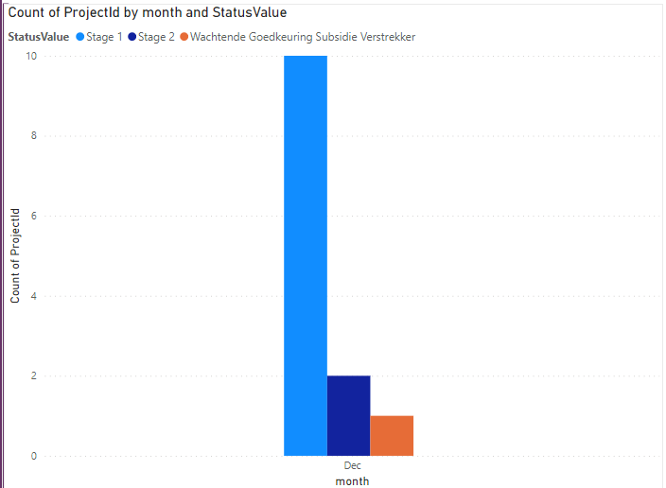  This clustered column chart displays the amount of projects in each stage. Along with what month they started. |  | Source: LowCodeProjectList & DIM_Date  Axis: Month  Legend: Status Value  Values: Count of ProjectId
4 | 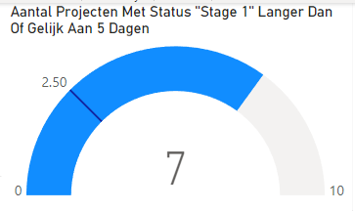  This gauge displays the number of projects that are in stage 1 for more then 5 days, along with a line displaying what the maximum of project allowed to be beyond 5 day. |  | Value: Status_Te_Lang_Stage_1  Maximum Value: Count_Stage_1  Target value: Target_Stage_1  Measure:  Count_Stage_1 = COUNTROWS(FILTER(LowCodeProjectList, LowCodeProjectList[StatusValue] = "Stage 1")) + 0  Status_Te_Lang_Stage_1 = COUNTROWS(FILTER(LowCodeProjectList, LowCodeProjectList[StatusValue] = "Stage 1" && DATEDIFF(LowCodeProjectList[Gemaakt], TODAY(), DAY) >= 5)) + 0  Target_Stage_1 = CALCULATE(CONVERT(0.25 * [Count_Stage_1], DOUBLE))
5 | 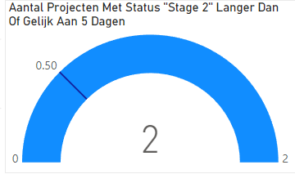  This gauge displays the number of projects that are in stage 2 for more then 5 days, along with a line displaying what the maximum of project allowed to be beyond 5 day. |  | Value: Status_Te_Lang_Stage_2  Maximum Value: Count_Stage_2  Target value: Target_Stage_2  Measure:  Count_Stage_2 = COUNTROWS(FILTER(LowCodeProjectList, LowCodeProjectList[StatusValue] = "Stage 2")) + 0  Status_Te_Lang_Stage_2 = COUNTROWS(FILTER(LowCodeProjectList, LowCodeProjectList[StatusValue] = "Stage 2" && DATEDIFF(LowCodeProjectList[Gemaakt], TODAY(), DAY) >= 10)) + 0  Target_Stage_2 = CALCULATE(0.25 * [Count_Stage_2])
6 | 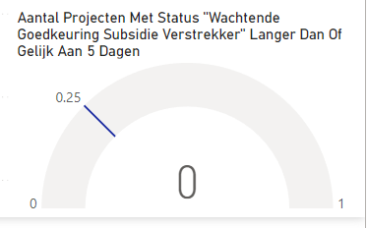  This gauge displays the number of projects that are in stage 3 for more then 5 days, along with a line displaying what the maximum of project allowed to be beyond 5 day. |  | Value: Status_Te_Lang_Stage_3  Maximum Value: Count_Stage_3  Target value: Target_Stage_3  Measure:  Count_Stage_3 = COUNTROWS(FILTER(LowCodeProjectList, LowCodeProjectList[StatusValue] = "Wachtende Goedkeuring Subsidie Verstrekker")) + 0  Status_Te_Lang_Stage_3 = COUNTROWS(FILTER(LowCodeProjectList, LowCodeProjectList[StatusValue] = "Wachtende Goedkeuring Subsidie Verstrekker" && DATEDIFF(LowCodeProjectList[Gemaakt], TODAY(), DAY) >= 15)) + 0  Target_Stage_3 = CALCULATE(0.25 * [Count_Stage_3])

11. Flow & Code Power Power BI ‘Instituten Overzicht’

This chapter will visualize and explain the ‘Instituten Overzicht’ dashboard in Power BI.

This translates into institute overview. This dashboard displays the amount of projects per institute for a timeframe. This Overview consist of 1 visualization and 2 slicers displayed in figure 21.

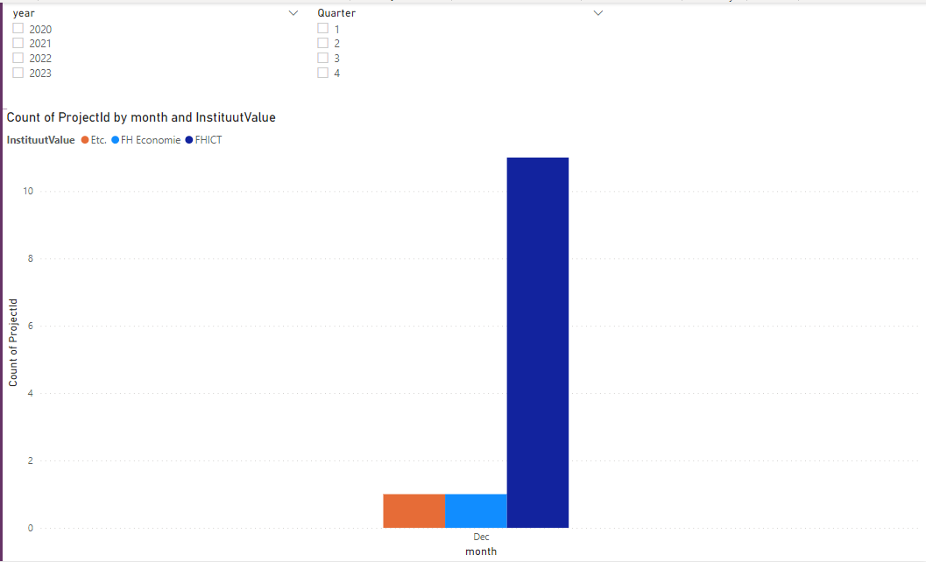
Figure 23 Instituten Overzicht Dashboard

Dashboard number |  | Explanation | Code
1 |   This slicer filters on in what year(s) projects started and filter the rest of the visualization on this page. |  | Source: Dim_Date  Field: Year  DIM_Date = ADDCOLUMNS(  CALENDARAUTO(),  "year", FORMAT([Date], "yyyy"),  "quarter", QUARTER([Date]),  "monthnr", MONTH([Date]),  "month", FORMAT([Date], "mmm"),  "week", WEEKNUM([Date], 2),  "wdnr", WEEKDAY([Date]-1),  "weekday", FORMAT([Date], "ddd"),  "weekend", IF(OR(WEEKDAY([Date]-1) = 6, WEEKDAY([Date]-1) = 7), TRUE(), FALSE())  )
2 | 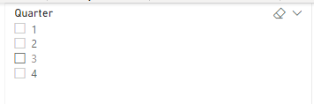  This slicer filters on in what quarter(s) projects started and filter the rest of the visualization on this page. |  | Source: Dim_Date  Field: Quarter  DIM_Date = ADDCOLUMNS(  CALENDARAUTO(),  "year", FORMAT([Date], "yyyy"),  "quarter", QUARTER([Date]),  "monthnr", MONTH([Date]),  "month", FORMAT([Date], "mmm"),  "week", WEEKNUM([Date], 2),  "wdnr", WEEKDAY([Date]-1),  "weekday", FORMAT([Date], "ddd"),  "weekend", IF(OR(WEEKDAY([Date]-1) = 6, WEEKDAY([Date]-1) = 7), TRUE(), FALSE())  )
3 | 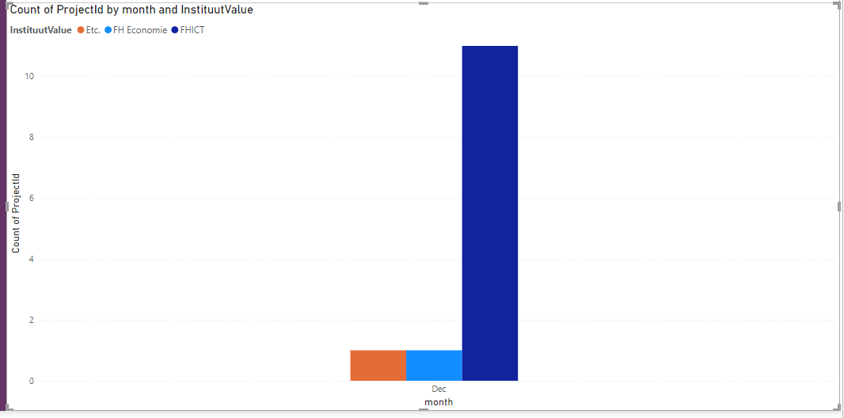  This clustered column chart uses the previous filters and displays the total amount of project for each institute with the starting month. |  | Source Dim_Date & LowCodeProjectList  Axis: Month  Legend: Instituut Value  Values: Count of ProjectId  DIM_Date = ADDCOLUMNS(  CALENDARAUTO(),  "year", FORMAT([Date], "yyyy"),  "quarter", QUARTER([Date]),  "monthnr", MONTH([Date]),  "month", FORMAT([Date], "mmm"),  "week", WEEKNUM([Date], 2),  "wdnr", WEEKDAY([Date]-1),  "weekday", FORMAT([Date], "ddd"),  "weekend", IF(OR(WEEKDAY([Date]-1) = 6, WEEKDAY([Date]-1) = 7), TRUE(), FALSE())  )

12. Flow & Code Power Power BI ‘Centre Of Expertise’

This chapter will visualize and explain the ‘Centre Of Expertise’ dashboard in Power BI.

This dashboard displays all the centers of expertise and the associated institutes. Along with a general count in which someone can see how many expertises an institute has, or how institutes have the same expertise. displayed in figure 21.

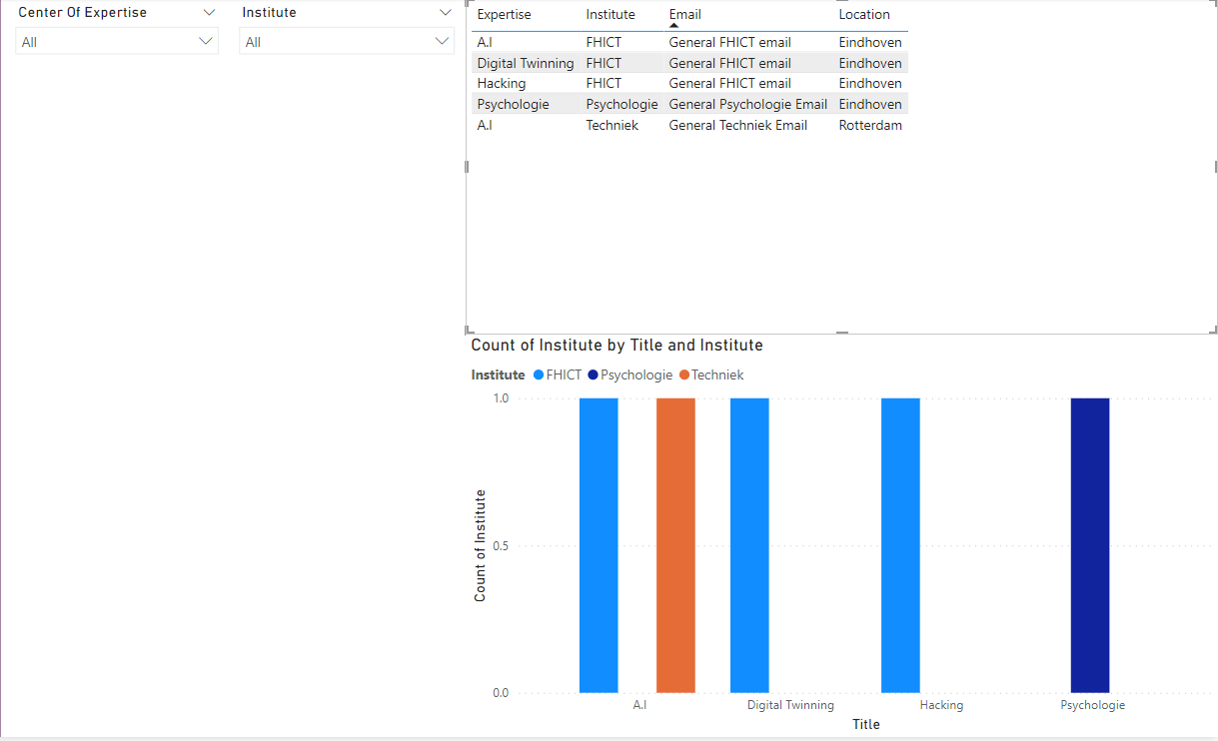
Figure 24 Centre Of Expertise Dashboard

Dashboard number |  | Explanation | Code
1 | 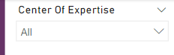  This slicer filters on in what Specific expertise someone is looking for. |  | -
2 | 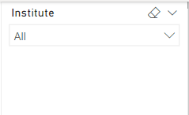  This slicer filters on in what Specific institute someone is looking for. |  | -
3 | 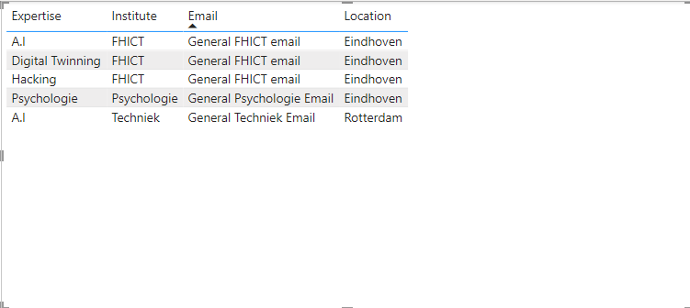  This table displays the information filted for by dashboard 1 & 2. It allows the user to see what the email of that specific expertise/institute is and the location. |  | Values:  Expertise, Institute, Email, Location
4 | 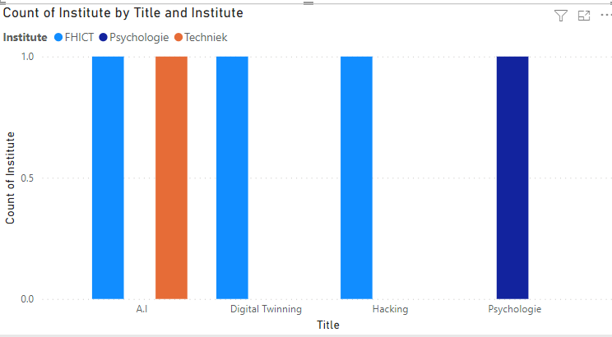  This Clusterd Colmn Chart displays information based on dashboard 1 & 2. It shows the user how many and which institutes have a certain expertise |  | Axis: Title  Legend: Institute  Values: Count of Institute

13. User Test And Peer Review

This chapter discusses, results of the user test (REFERENCE USER TEST) and the peer review. As a result changes are made to the Proof-Of-Concept which are also discussed in this chapter.

13.1 User test

The user test was conducted by Brainwave with firstly, Bart van Gennip a professor. Secondly, Dries van den Enden a project leader and lately, Mark Aelmans a project controller. These three Fontys employees have different roles during the project proposal stage resulting in diverse requirements from the Proof-Of-Concept.

The testers were given four different scenarios. First two are based on the automatizations created for the project proposal stage by Brainwave. Which uses Microsoft Forms and Microsoft Power Automate. For the first scenario the testers had to complete the form ‘project aanvraag stage 1’. All users were able to complete this stage with an average time of 3:04 minutes, this time will obviously increase as the testers were allowed to do this for a fictional project. The second scenario required the users to open the form ‘project aanvraag stage 2’ and fill in the project id. Which they received in an email after finishing stage 1. All users were able to complete this stage with an average time 28 seconds.

The last two scenarios are based on the Power BI dashboards which are created from the data gathered during the automatization. The third scenario asked tested to search for how many projects there currently are and the status of December 2021. The average time of these test was 1:33 minutes with one tester failing to complete the scenario. The fourth scenario required the testers to find more information on the project “Fontys Lowcode” by using a drill-through on one of the bars in the chart. All users were able to complete this stage with an average time of 1:39 minutes.

13.2 Peer Review

For the peer review the client Rutger Lippits was chosen. Rutger has worked closely with Brainwave in order to accomplish a solid Proof-Of-Concept and has extensive knowledge on all the needs roles may have.

This occurred on 16th of December 2021, in this meeting Brainwave took Rutger step by step through every aspect of the Proof-Of-concept, afterwards Rutger was presented with the same user test as the other three Fontys employees.

13.3 Results

Table 1 demonstrates all the feedback provided to Brainwave for the Power Automate Proof-Of-Concept. Unfortunately, Brainwave will not be able to change the Power Automate Flow, as a previous round of feedback has been implanted already and doing so again would cause a lack of time for improving Power BI, creating a transition document and answering research question 5. This feedback will be noted in the recommendation for future development of the automatization for Fontys projects. There is one exception, the last email is improved with the ProjectId mentioned several times.

Table 5 User Test Power Automate feedback
Times mentioned | Feedback
3 | Mention the names of stakeholders in the email
3 | ProjectID is unclear in the email and forms
2 | Preferable having the link in the last email automatically fill in the ProjectID
1 | Initiator is the on that has contributed in writing the proposal but not always the one applying for the subsidies.
1 | Forms does not take ‘.’ and ‘,’ into consideration
1 | Ad-blocker may cause the forms to not function properly(especially date picker)
1 | Prefers the communication to be via teams instead of email
1 | In the stage 2 forms, change the question “institute” to something slightly different which will result in the same answer but will not feel like answering the same question each time. The example provided is “welk instituut beoordeeld deze aavraag”
1 | Change forms “project id” to “PROJECT ID (zie email)
1 | Different type of projects need different input fields. Examples are internal projects are not granted subsidies but are still required to provide one.
1 | Provide the initiator with more feedback from the employees approving the project, instead of all at once. Also providing the ability for stakeholder to look into the other approvals.

Table 5 demonstrates all the feedback provided to Brainwave for the Power BI Proof-Of-Concept. This will be the first round of feedback provided to Brainwave on Power BI. Therefor some of the feedback will be used and implemented. However only feedback that Brainwave deems within scope is implemented, reasoning being that taking on additional work beyond the scope close to the deadline would negatively impact Brainwave’s schedule.

Table 6 User Test Feedback Power BI
Times mentioned | Feedback | Status
2 | Name ‘initiator overzicht’ is unclear | Changed
2 | Finding the Project name in the “initiator overzicht” is difficult | Changed
1 | Consider project duration in the dashboard. | Beyond scope
1 | What bars are selected in the bar chart is not fully with some only the transpiration effect. | Changed
1 | In “Projecten Status Overzicht” have an absolute number of projects instead of only bar charts | Changed
1 | The navigation menu needs to be clearer | Beyond scope
1 | A separate overview of specific project instead of a drill-through | Beyond scope
1 | Add textual explanation | Beyond scope
1 | Check-list of project that users find interesting | Beyond scope
1 | Add an indication on the status of budget used | Beyond scope

The first change is done by adding another Slicer in the ‘initiator overzicht’ displayed in figure 22, adding an additional filter option. An Initiator was previously only able to select a specific project by pressing it in the bar chart. By adding this slicer, it now also solved the issue of not being clear what is now being selected and accessible for the user to select a project. The last change was adding the total number of project for an initiator. This has to previously be done by counting the amount of projects from the bar chart. Now with the addition of the card displayed in figure 23 it now is also displayed as a numerical value.

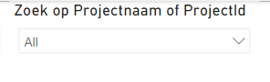
Figure 25 addition slicer in “initiator overzicht”
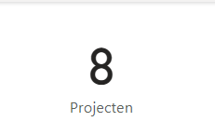
Figure 26 Change total amount of projects in “Initiator Overzicht”
Table

13.4 Peer Review Feed Back
Brainwave has conducted a peer review on 16th of December, Brainwave has taken Rutger through the Power BI Proof-Of-Concept created by Brainwave. The following results are displayed in table 7. This feedback will be used to alter the previous elaborated Power BI dashboards.
Table 7 Peer Review Feedback Power BI
Feedback | Status
‘Instituten Overzicht’ separate the status from status to institute | Changed
‘Projecten Status Overzicht’ change name to ‘Project Controller Overzicht’ | Changed
Add an additional filter on the type of project (subsidy, internal, zakelijke dienst) | Changed
More drill-through links in the dashboards | -
Add an additional gauge diagram to the ‘Project Status Overzicht’ | Changed
Couple institutes to centre of expertise by using general institute emails. | Changed
Overview of centre of expertise as several institutes may possess the same expertise | Changed

‘Instituten Overzicht’ has been changed up significantly compared to figure 24(vorige instituten overzicht) the stacked column chart has been altered to now display based on institute instead of project status, the project status is now displayed as a stack within the bar. Along with a new slicer which filters on the project type, to create the possibility for distinguishing between those. Something which will be relevant during the rollout of the project beyond subsidy projects.

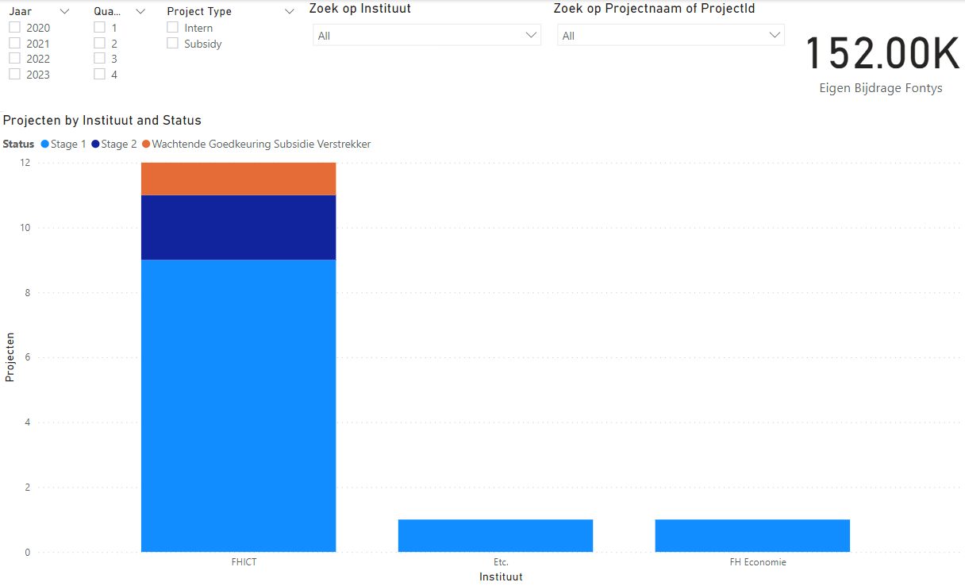
Figure 27 New Dashboard 'instituten Overzicht'
‘Project Controller Overzicht’ has changed, it was previously named ‘Projecten Status Overzicht’. An additional two-gauge graphs have been added to the dashboard. These gauge’s display the amount a project will cost Fontys and the amount of subsidies being granted by the subsidy provider. As Rutger mentioned on the 16th of December, these are two figures are detrimental for establishing budgets. This overview now better helps stakeholders in determining if a project is able to be pursued due to the amount of funding required. Leading to better decision making during the approval stage.

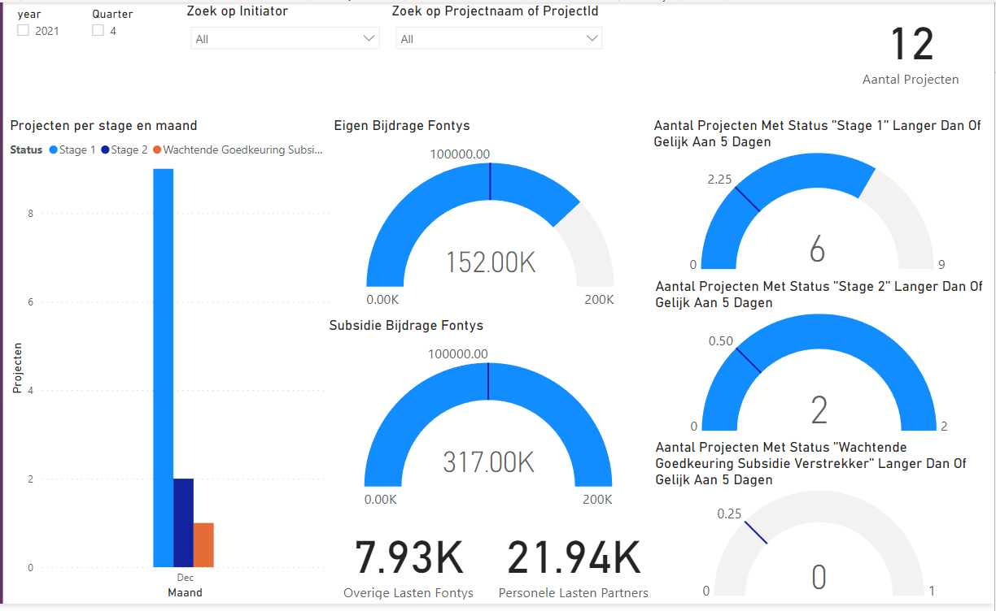
Figure 28 New Dashboard 'Project Controller Overzicht'
As a result of Rutger’s feedback, a Dashboard has been created. It is called ‘Center Of Expertise displayed in figure 26. Rutger Explained that Fontys is working on a new format called “The centre of expertise”. The goal is to create different fields of expertise, with the possibility of an expertise present at several institutes. This dashboard allows the user to filter on an expertise and or institute. This filter effects the table which contains an email and location of the institute and expertise. This makes it possible for staff member to get in touch with one another and see where the staff member is located. There is also a clustered column chart which displays the expertise and institutes in a chart. Making it possible to get a general oversight in how many expertise an institute has or how many institutes share the same expertise.

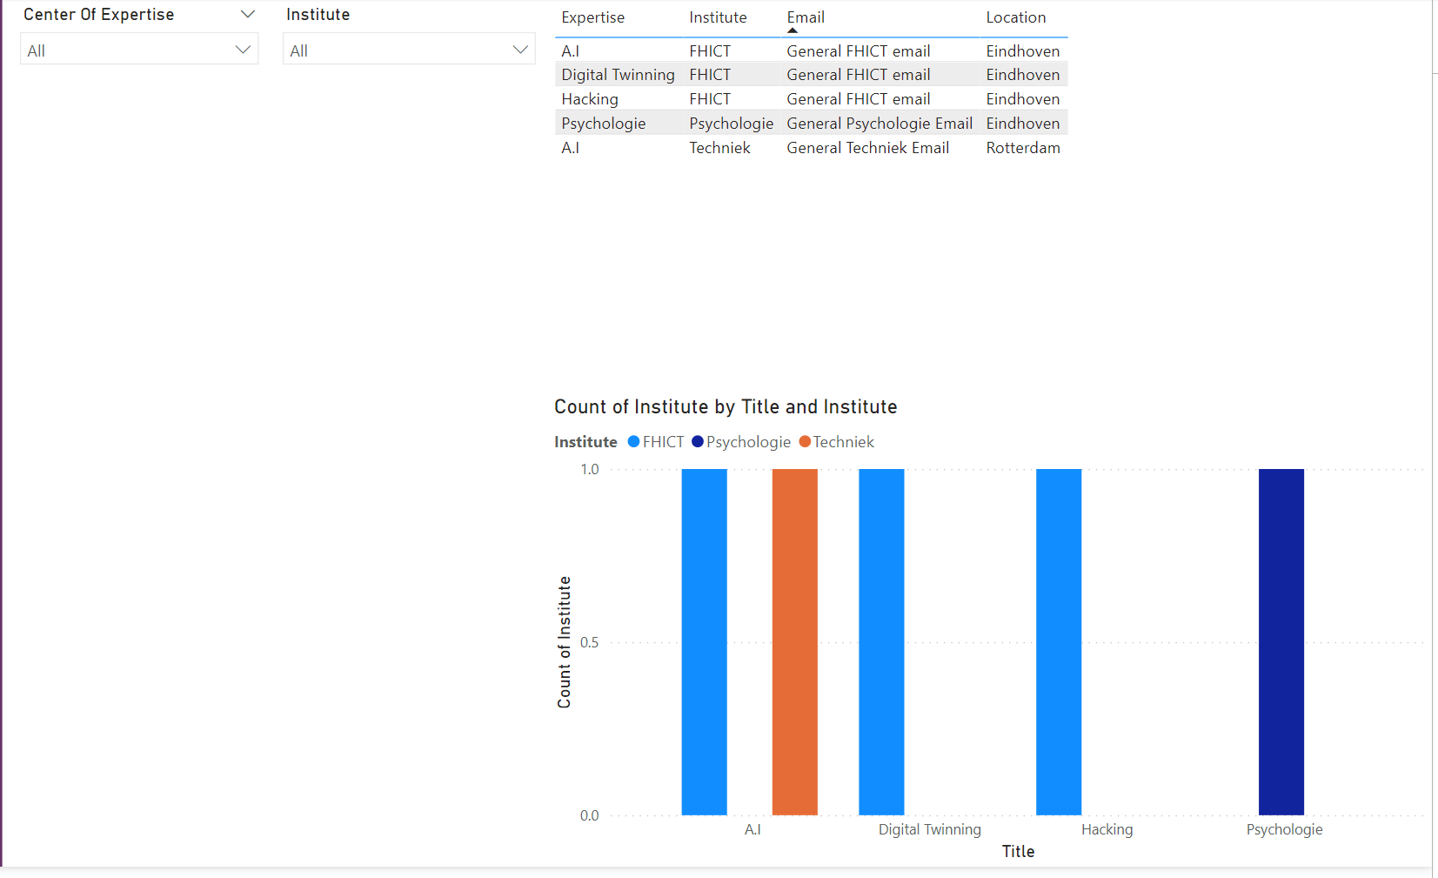
Figure 29 New Dashboard Center Of Expertise

